UNITED STATES
SECURITIES AND EXCHANGE COMMISSION
Washington, D.C. 20549

FORM 6-K

Report of Foreign Private Issuer
Pursuant to Rule 13a-16 or 15d-16 under
the Securities Exchange Act of 1934

Report on Form 6-K dated July 23, 2026
(Commission File No. 1-13202)

Nokia Corporation
Karakaari 7
FI-02610 Espoo
Finland

(Translation of the registrant’s name into English and address of registrant’s principal executive office)

Indicate by check mark whether the registrant files or will file annual reports under cover of Form 20-F or Form 40-F:
Form 20-F: ☒ |  | Form 40-F: ☐

Enclosures:

 | • | Nokia Corporation Report for Q2 and Half Year 2026
 | • | Nokia provides recast comparative financial information reflecting the presentation of Fixed Wireless Access CPE and Enterprise Campus Edge businesses as discontinued operations

 |  | 1  STOCK EXCHANGE RELEASE 23 July 2026

Nokia Corporation
Half Year financial report
23 July 2026 at 08:00 EEST

Nokia Corporation Report for Q2 and Half Year 2026

Solid Q2 fueled by growing AI & Cloud demand

 | • | Q2 net sales grew 9% y-o-y on a constant currency basis (+8% reported).
 | • | Network Infrastructure net sales grew 12% y-o-y on a constant currency basis, led by Optical Networks growing 20% and IP Networks growing 16%. Net sales to AI & Cloud customers grew 105%.
 | • | Mobile Infrastructure net sales grew with a stable year-on-year profit contribution driven by product mix.
 | • | Q2 comparable gross margin expanded 70bps y-o-y to 46.0%. Reported gross margin rose 60bps to 44.6%.
 | • | Q2 comparable operating margin increased 70bps y-o-y to 9.0%. Reported operating margin declined 430bps to (1.0)% due to a faster pace of restructuring.
 | • | Q2 comparable diluted EPS for the period of EUR 0.07; reported diluted EPS for the period of EUR 0.00.
 | • | Nokia has reclassified two businesses previously in its Portfolio Businesses segment into discontinued operations.
 | • | Operationally, Nokia's full year outlook is unchanged. The presentation of these two businesses as discontinued operations has led to a EUR 0.1 billion technical revision to the full year comparable operating profit range. Nokia's outlook is now for EUR 2.1 to 2.6 billion of comparable operating profit.

"Q2 demonstrates our strategy is delivering results. Since we set out our plan late last year, Team Nokia has focused on maximizing our opportunity in the AI supercycle. I am encouraged by the execution and progress we have made in a short period of time. We enter the second half with momentum and remain on track to deliver somewhat above the midpoint of our comparable operating profit guidance.

In Q2, our AI & Cloud order intake was EUR 2.8 billion, while sales more than doubled year-on-year. The strength was broad-based, as we secured long-term orders in both Optical Networks and IP Networks. We expect around half of these orders to convert to revenue over the next twelve months. Demand remains strong, while supply continues to be the main industry constraint, prompting our customers to place longer-term orders.

As AI evolves, trusted connectivity becomes even more critical and we are delivering market leading innovation that helps customers differentiate and capture value in this new era. Last week we launched the industry’s first commercial AI-RAN platform, which will help customers unlock more from their networks, including more than 100% spectral efficiency gains by 2028. These benefits will be tangible in 5G networks and the platform provides a software upgrade path to 6G. This innovation is one example of how we unlock value for our customers and generate returns for our shareholders."

2

STOCK EXCHANGE RELEASE 23 July 2026

Justin Hotard, President and CEO

This is a summary of the Nokia Corporation Report for Q2 and Half Year 2026 published today. Nokia only publishes a summary of its financial reports in stock exchange releases. The summary focuses on Nokia Group's financial information as well as on Nokia's outlook. The detailed, segment-level discussion will be available in the complete financial report hosted at www.nokia.com/financials. Investors should not solely rely on summaries of Nokia's financial reports and should also review the complete reports with tables.

FINANCIAL RESULTS

EUR million (except for EPS in EUR) |  | Q2'26 |  |  |  | Q2'25 |  |  |  | YoY  change |  |  |  | Q1-Q2'26 |  |  |  | Q1-Q2'25 |  |  |  | YoY  change
Reported results
Net sales |  |  | 4 815 |  |  |  | 4 443 |  |  |  | 8 | % |  |  | 9 248 |  |  |  | 8 743 |  |  |  | 6 | %
Gross margin % |  |  | 44.6 | % |  |  | 44.0 | % |  |  | 60 | bps |  |  | 44.6 | % |  |  | 43.0 | % |  |  | 160 | bps
Operating (loss)/profit |  |  | (50 | ) |  |  | 147 |  |  |  |  |  |  |  | 33 |  |  |  | 151 |  |  |  | (78 | )%
Operating margin % |  |  | (1.0 | )% |  |  | 3.3 | % |  |  | (430 | )bps |  |  | 0.4 | % |  |  | 1.7 | % |  |  | (130 | )bps
Profit from continuing operations |  |  | 27 |  |  |  | 99 |  |  |  | (73 | )% |  |  | 131 |  |  |  | 60 |  |  |  | 118 | %
Loss from discontinued operations |  |  | (22 | ) |  |  | (3 | ) |  |  |  |  |  |  | (39 | ) |  |  | (23 | )
Profit for the period |  |  | 5 |  |  |  | 96 |  |  |  | (95 | )% |  |  | 92 |  |  |  | 36 |  |  |  | 156 | %
EPS for the period, diluted |  |  | 0.00 |  |  |  | 0.02 |  |  |  | (100 | )% |  |  | 0.02 |  |  |  | 0.01 |  |  |  | 100 | %
Net cash and interest-bearing financial investments |  |  | 2 776 |  |  |  | 2 879 |  |  |  | (4 | )% |  |  | 2 776 |  |  |  | 2 879 |  |  |  | (4 | )%
Comparable results
Net sales |  |  | 4 815 |  |  |  | 4 448 |  |  |  | 8 | % |  |  | 9 251 |  |  |  | 8 748 |  |  |  | 6 | %
Constant currency and portfolio YoY change |  |  |  |  |  |  |  |  |  |  | 9 | % |  |  |  |  |  |  |  |  |  |  | 7 | %
Gross margin % |  |  | 46.0 | % |  |  | 45.3 | % |  |  | 70 | bps |  |  | 46.0 | % |  |  | 44.1 | % |  |  | 190 | bps
Operating profit |  |  | 434 |  |  |  | 367 |  |  |  | 18 | % |  |  | 735 |  |  |  | 576 |  |  |  | 28 | %
Operating margin % |  |  | 9.0 | % |  |  | 8.3 | % |  |  | 70 | bps |  |  | 7.9 | % |  |  | 6.6 | % |  |  | 130 | bps
Profit for the period |  |  | 414 |  |  |  | 252 |  |  |  | 64 | % |  |  | 726 |  |  |  | 426 |  |  |  | 70 | %
EPS for the period, diluted |  |  | 0.07 |  |  |  | 0.04 |  |  |  | 75 | % |  |  | 0.13 |  |  |  | 0.08 |  |  |  | 63 | %

Segment results |  | Network  Infrastructure |  |  |  |  |  |  |  | Mobile  Infrastructure |  |  |  |  |  |  |  | Portfolio  Businesses
EUR million |  | Q2'26 |  |  |  | Q2'25 |  |  |  | Q2'26 |  |  |  | Q2'25 |  |  |  | Q2'26 |  |  |  | Q2'25
Net sales |  |  | 2 037 |  |  |  | 1 825 |  |  |  | 2 680 |  |  |  | 2 531 |  |  |  | 94 |  |  |  | 89
YoY change |  |  | 12 | % |  |  |  |  |  |  | 6 | % |  |  |  |  |  |  | 6 | %
Constant currency YoY change |  |  | 12 | % |  |  |  |  |  |  | 7 | % |  |  |  |  |  |  | 6 | %
Gross margin % |  |  | 42.7 | % |  |  | 40.3 | % |  |  | 49.3 | % |  |  | 50.0 | % |  |  | 28.7 | % |  |  | 16.9 | %
Operating profit/(loss) |  |  | 166 |  |  |  | 117 |  |  |  | 310 |  |  |  | 310 |  |  |  | 0 |  |  |  | (11 | )
Operating margin % |  |  | 8.1 | % |  |  | 6.4 | % |  |  | 11.6 | % |  |  | 12.2 | % |  |  | 0.0 | % |  |  | (12.4 | )%

OUTLOOK

 | Full Year 2026
Comparable operating profit(1),(2) | EUR 2.1 billion to EUR 2.6 billion (technical revision from EUR 2.0 billion to 2.5 billion)
1 Please refer to Alternative performance measures section in Nokia Corporation Report for Q2 and Half Year 2026 for a full explanation of how this term is defined.
2 Outlook is based on a EUR:USD rate of 1.14 for the remainder of 2026.

3

STOCK EXCHANGE RELEASE 23 July 2026

Operationally, Nokia's outlook is unchanged for full year 2026. However, a change in the presentation of two businesses (Fixed Wireless Access CPE and Enterprise Campus Edge) which are now treated as discontinued operations revises the comparable operating profit outlook by EUR 0.1 billion. As a result Nokia's comparable operating profit guidance range is now EUR 2.1 to 2.6 billion (was EUR 2.0 to 2.5 billion).

The outlook and the underlying outlook assumptions are forward-looking statements subject to a number of risks and uncertainties as described or referred to in the Risk Factors section later in this release.

Along with Nokia's official outlook target provided above, Nokia provides the below assumptions that support the group level financial outlook for 2026.

 | Full year 2026 | Comment
H2 seasonality |  | Net sales: Nokia assumes a 3% to 7% q-o-q increase in net sales in Q3.  Comparable operating profit: Nokia assumes comparable operating profit will be largely flat from Q2 into Q3 due to the phasing of software revenue recognition. Nokia then expects a meaningful increase in Q4.
Network Infrastructure net sales growth(1) | 12 - 14% | This incorporates an assumption for combined IP and Optical Networks to grow 18-20% in 2026.
Comparable financial income and expenses | Positive EUR 150 to 250 million
Comparable income tax rate | ~26-27% | Nokia's effective tax rate remains sensitive to geographic mix.
Cash outflows related to income taxes | EUR 500 million
Capital expenditures | EUR 800 - 900 million  (update) | Reduced assumption primarily due to changes in real estate plans. Nokia continues to invest in expanding Optical manufacturing capacity.
Free cash flow conversion from comparable operating profit | 55% to 75% | FCF conversion will be influenced by customer payment timing, evolution of regional demand and capex timing.
Restructuring and associated charges related to cost savings programs | EUR 800 million  (update) | Nokia has provided an update on its restructuring actions below.
Restructuring and associated cash outflows | EUR 700 - 800 million  (update) | Restructuring and related outflows relating to all Nokia restructuring programs (previous assumption based only on 2023-2026 program).
1 Net sales growth assumption is on a constant currency and portfolio basis.

RESTRUCTURING UPDATE

Acceleration of restructuring actions

Consistent with Nokia’s objective of increasing agility and reallocating resource toward growth opportunities, the company has accelerated certain restructuring actions. In total, this means that Nokia now expects related charges of EUR 800 million in 2026.

 | • | 2023 - 2026 restructuring program: In Oct 2023, Nokia initiated a program to achieve between EUR 800 million and 1 200 million in gross cost savings by the end of 2026. Nokia is currently tracking to achieve the high-end of that range and continues to expect EUR 250 million of restructuring charges in 2026 related to the conclusion of the program.
 | • | Simplifying Nokia’s operating structure in China: In January, Nokia announced that having taken full ownership of its joint venture in China it would integrate the operations into its global operating model. At the time this was expected to take 2-3 years with integration charges of between EUR 350 and 400 million and the expectation to deliver EUR 200 million in cost savings. Nokia now expects to recognize EUR 350 million of the planned integration charges by the end of 2026 as we target to complete the integration within 2 years.
 | • | Additional restructuring actions primarily in Europe: As a further step in simplifying Nokia’s operating model and allocating resources towards growth opportunities, the company has already initiated additional restructuring programs primarily in Europe. These programs are expected to lead to restructuring charges of EUR 200 million in 2026.

4

STOCK EXCHANGE RELEASE 23 July 2026

SHAREHOLDER DISTRIBUTION

Dividend

Under the authorization by the Annual General Meeting held on 9 April 2026, the Board of Directors may resolve on the distribution of an aggregate maximum of EUR 0.14 per share to be paid in respect of financial year 2025. The authorization will be used to distribute dividend and/or assets from the reserve for invested unrestricted equity in four installments during the authorization period unless the Board decides otherwise for a justified reason.

On 23 July 2026, the Board resolved to distribute a dividend of EUR 0.04 per share. The dividend record date is 28 July 2026 and the dividend will be paid on 6 August 2026. The actual dividend payment date outside Finland will be determined by the practices of the intermediary banks transferring the dividend payments.

Following this announced distribution, the Board’s remaining distribution authorization is a maximum of EUR 0.06 per share.

ADDITIONAL TOPICS

Businesses moved to discontinued operations

In Q2 2026, Nokia classified its Fixed Wireless Access CPE and Enterprise Campus Edge businesses as discontinued operations. Nokia reached an agreement to sell its Fixed Wireless Access CPE business to Inseego and Nokia also deems it highly probable it will reach an agreement to sell Enterprise Campus Edge business. Nokia is today publishing a separate release that provides a recast of Nokia's financial results for each quarter in 2025 and Q1 2026. If Nokia had not treated these businesses as discontinued operations in Q2 2026, net sales would have been EUR 66 million higher and comparable operating profit would have been EUR 13 million lower.

Nokia acquires further U.S. optical manufacturing capacity

Nokia continues to expand its long-term optical component manufacturing plans. Nokia remains on track with its new San Jose Fab to begin ramping production later in Q4 2026 and announced during Q2 2026 an investment to increase its advanced test and packaging capacity in Pennsylvania by 10x beginning in Q3 2026. These investments support the demand expected in 2027 and 2028.

As part of its long-term capacity planning, Nokia has entered into a definitive agreement to acquire NXP's Chandler Semiconductor Fabrication campus in Arizona. Subject to the receipt of certain regulatory approvals, Nokia will initially lease manufacturing capacity in a portion of the facility on the site starting in early 2027 and will convert the site to Indium Phosphide semiconductor production for optical components. Nokia will then acquire the full site, with the transaction expected to close in Q1 2029. The transaction further strengthens Nokia's in-house compound semiconductor manufacturing capabilities through the addition of a highly experienced team with deep industry expertise. It also adds U.S.-based Indium Phosphide semiconductor manufacturing capacity at a time when secure and scalable domestic supply is becoming increasingly important for the broader U.S. technology ecosystem and the AI supercycle build out.

5

STOCK EXCHANGE RELEASE 23 July 2026

RISK FACTORS

Nokia and its businesses are exposed to a number of risks and uncertainties which include but are not limited to:

 | • | Competitive intensity, which is expected to continue at a high level as some competitors seek to take share;
 | • | Changes in customer network investments related to their ability to monetize the network or opportunities related to AI and data center growth;
 | • | Our ability to ensure competitiveness of our product roadmaps and costs through additional R&D investments;
 | • | Our ability to procure or manufacture certain components (e.g. semiconductors), the costs thereof and our ability to align our inventory levels and supplier commitments with customer demand
 | • | Disturbance in the global supply chain;
 | • | Impact of inflation, increased global macro-uncertainty, major currency fluctuations, changes in tariffs and higher interest rates;
 | • | Potential economic impact and disruption of global pandemics;
 | • | War or other geopolitical conflicts, disruptions and potential costs thereof;
 | • | Other macroeconomic, industry and competitive developments;
 | • | Timing and value of new, renewed and existing patent licensing agreements with licensees;
 | • | Results in technology licensing; costs to protect and enforce our intellectual property rights; on-going litigation with respect to licensing and regulatory landscape for patent licensing;
 | • | The outcomes of on-going and potential disputes and litigation;
 | • | Our ability to execute, complete, successfully integrate and realize the expected benefits from transactions;
 | • | Timing of completions and acceptances of certain projects;
 | • | Our product and regional mix;
 | • | Uncertainty in forecasting income tax expenses and cash outflows, over the long-term, as they are also subject to possible changes due to business mix, the timing of patent licensing cash flow and changes in tax legislation, including potential tax reforms in various countries and OECD initiatives;
 | • | Our ability to utilize our Finnish deferred tax assets and their recognition on our balance sheet;
 | • | Our ability to meet our sustainability and other ESG targets, including our targets relating to greenhouse gas emissions;

as well the risk factors specified under Forward-looking statements of this release, and our 2025 annual report on Form 20-F published on 5 March 2026 under Operating and financial review and prospects-Risk factors.

6

STOCK EXCHANGE RELEASE 23 July 2026

FORWARD-LOOKING STATEMENTS

Certain statements herein that are not historical facts are forward-looking statements. These forward-looking statements reflect Nokia's current expectations and views of future developments and include statements regarding: A) expectations, plans, benefits or outlook related to our strategies, projects, programs, product launches, growth management, licenses, sustainability and other ESG targets, operational key performance indicators and decisions on market exits; B) expectations, plans or benefits related to future performance of our businesses (including the expected impact, timing and duration of potential global pandemics, geopolitical conflicts and the general or regional macroeconomic conditions on our businesses, our supply chain, the timing of market changes or turning points in demand and our customers’ businesses) and any future dividends and other distributions of profit; C) expectations and targets regarding financial performance and results of operations, including market share, prices, net sales, income, margins, cash flows, cost savings, the timing of receivables, operating expenses, provisions, impairments, tariffs, taxes, currency exchange rates, hedging, investment funds, inflation, product cost reductions, competitiveness, value creation, revenue generation in any specific region, and licensing income and payments; D) our ability to execute, expectations, plans or benefits related to transactions, investments and changes in organizational structure and operating model; E) impact on revenue with respect to litigation/renewal discussions; and F) any statements preceded by or including "anticipate", “continue”, “believe”, “envisage”, “expect”, “aim”, “will”, “target”, “may”, “would”, “could“, "see", “plan”, “ensure” or similar expressions. These forward-looking statements are subject to a number of risks and uncertainties, many of which are beyond our control, which could cause our actual results to differ materially from such statements. These statements are based on management’s best assumptions and beliefs in light of the information currently available to them. These forward-looking statements are only predictions based upon our current expectations and views of future events and developments and are subject to risks and uncertainties that are difficult to predict because they relate to events and depend on circumstances that will occur in the future. Factors, including risks and uncertainties that could cause these differences, include those risks and uncertainties identified in the Risk Factors above.

ANALYST WEBCAST

 | • | Please note that Nokia's webcast time has changed and will begin on 23 July 2026 at 3.00 p.m. Finnish time (EEST). The webcast will last approximately 60 minutes.
 | • | The webcast will be a presentation followed by a Q&A session. Presentation slides will be available for download at www.nokia.com/financials.
 | • | A link to the webcast will be available at www.nokia.com/financials.
 | • | Media representatives can listen in via the link, or alternatively call +44 20 3428 1399. Conference ID is 050-573-800.

FINANCIAL CALENDAR

 | • | Nokia plans to publish its third quarter and January-September 2026 results on 22 October 2026.

About Nokia

Nokia is a global leader in connectivity for the AI era. With expertise across fixed, mobile, and transport networks, we’re advancing connectivity to secure a brighter world.

Inquiries:

Nokia
Communications
Phone: +358 10 448 4900
Email: press.services@nokia.com
Maria Vaismaa, Vice President, Corporate Communications

Nokia
Investor Relations
Phone: +358 931 580 507
Email: investor.relations@nokia.com

 | 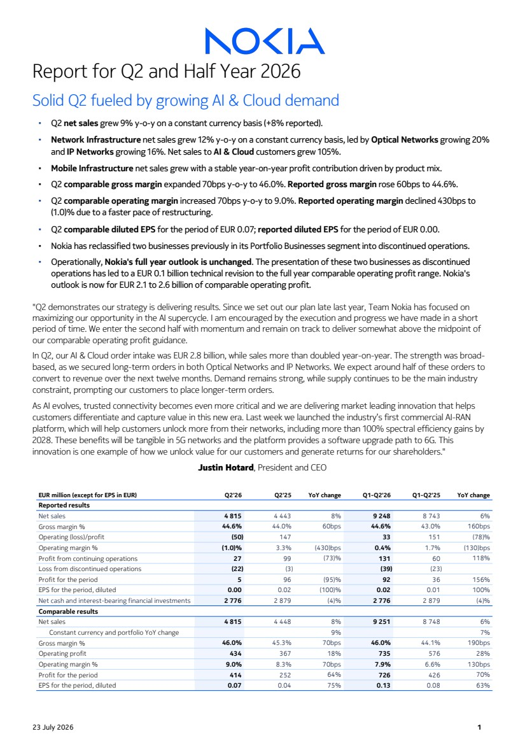 | Report for Q2 and Half Year 2026 Solid Q2 fueled by growing AI & Cloud demand ▪ Q2 net sales grew 9% y-o-y on a constant currency basis (+8% reported). ▪ Network Infrastructure net sales grew 12% y-o-y on a constant currency basis, led by Optical Networks growing 20% and IP Networks growing 16%. Net sales to AI & Cloud customers grew 105%. ▪ Mobile Infrastructure net sales grew with a stable year-on-year profit contribution driven by product mix. ▪ Q2 comparable gross margin expanded 70bps y-o-y to 46.0%. Reported gross margin rose 60bps to 44.6%. ▪ Q2 comparable operating margin increased 70bps y-o-y to 9.0%. Reported operating margin declined 430bps to (1.0)% due to a faster pace of restructuring. ▪ Q2 comparable diluted EPS for the period of EUR 0.07; reported diluted EPS for the period of EUR 0.00. ▪ Nokia has reclassified two businesses previously in its Portfolio Businesses segment into discontinued operations. ▪ Operationally, Nokia's full year outlook is unchanged. The presentation of these two businesses as discontinued operations has led to a EUR 0.1 billion technical revision to the full year comparable operating profit range. Nokia's outlook is now for EUR 2.1 to 2.6 billion of comparable operating profit. "Q2 demonstrates our strategy is delivering results. Since we set out our plan late last year, Team Nokia has focused on maximizing our opportunity in the AI supercycle. I am encouraged by the execution and progress we have made in a short period of time. We enter the second half with momentum and remain on track to deliver somewhat above the midpoint of our comparable operating profit guidance. In Q2, our AI & Cloud order intake was EUR 2.8 billion, while sales more than doubled year-on-year. The strength was broad-based, as we secured long-term orders in both Optical Networks and IP Networks. We expect around half of these orders to convert to revenue over the next twelve months. Demand remains strong, while supply continues to be the main industry constraint, prompting our customers to place longer-term orders. As AI evolves, trusted connectivity becomes even more critical and we are delivering market leading innovation that helps customers differentiate and capture value in this new era. Last week we launched the industry’s first commercial AI-RAN platform, which will help customers unlock more from their networks, including more than 100% spectral efficiency gains by 2028. These benefits will be tangible in 5G networks and the platform provides a software upgrade path to 6G. This innovation is one example of how we unlock value for our customers and generate returns for our shareholders." Justin Hotard, President and CEO EUR million (except for EPS in EUR) Q2'26 Q2'25 YoY change Q1-Q2'26 Q1-Q2'25 YoY change Reported results Net sales 4 815 4 443 8% 9 248 8 743 6% Gross margin % 44.6% 44.0% 60bps 44.6% 43.0% 160bps Operating (loss)/profit (50) 147 33 151 (78)% Operating margin % (1.0)% 3.3% (430)bps 0.4% 1.7% (130)bps Profit from continuing operations 27 99 (73)% 131 60 118% Loss from discontinued operations (22) (3) (39) (23) Profit for the period 5 96 (95)% 92 36 156% EPS for the period, diluted 0.00 0.02 (100)% 0.02 0.01 100% Net cash and interest-bearing financial investments 2 776 2 879 (4)% 2 776 2 879 (4)% Comparable results Net sales 4 815 4 448 8% 9 251 8 748 6% Constant currency and portfolio YoY change 9% 7% Gross margin % 46.0% 45.3% 70bps 46.0% 44.1% 190bps Operating profit 434 367 18% 735 576 28% Operating margin % 9.0% 8.3% 70bps 7.9% 6.6% 130bps Profit for the period 414 252 64% 726 426 70% EPS for the period, diluted 0.07 0.04 75% 0.13 0.08 63% 23 July 2026 1
 | 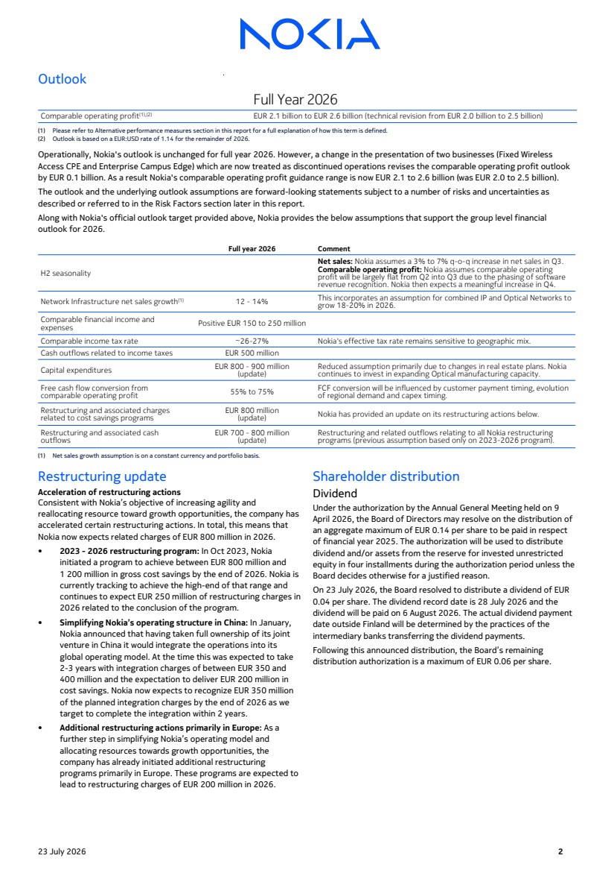 | Outlook Full Year 2026 Comparable operating profit(1),(2) EUR 2.1 billion to EUR 2.6 billion (technical revision from EUR 2.0 billion to 2.5 billion) (1) Please refer to Alternative performance measures section in this report for a full explanation of how this term is defined. (2) Outlook is based on a EUR:USD rate of 1.14 for the remainder of 2026. Operationally, Nokia's outlook is unchanged for full year 2026. However, a change in the presentation of two businesses (Fixed Wireless Access CPE and Enterprise Campus Edge) which are now treated as discontinued operations revises the comparable operating profit outlook by EUR 0.1 billion. As a result Nokia's comparable operating profit guidance range is now EUR 2.1 to 2.6 billion (was EUR 2.0 to 2.5 billion). The outlook and the underlying outlook assumptions are forward-looking statements subject to a number of risks and uncertainties as described or referred to in the Risk Factors section later in this report. Along with Nokia's official outlook target provided above, Nokia provides the below assumptions that support the group level financial outlook for 2026. Full year 2026 Comment H2 seasonality Net sales: Nokia assumes a 3% to 7% q-o-q increase in net sales in Q3. Comparable operating profit: Nokia assumes comparable operating profit will be largely flat from Q2 into Q3 due to the phasing of software revenue recognition. Nokia then expects a meaningful increase in Q4. Network Infrastructure net sales growth(1) 12 - 14% This incorporates an assumption for combined IP and Optical Networks to grow 18-20% in 2026. Comparable financial income and expenses Positive EUR 150 to 250 million Comparable income tax rate ~26-27% Nokia's effective tax rate remains sensitive to geographic mix. Cash outflows related to income taxes EUR 500 million Capital expenditures EUR 800 - 900 million (update) Reduced assumption primarily due to changes in real estate plans. Nokia continues to invest in expanding Optical manufacturing capacity. Free cash flow conversion from comparable operating profit 55% to 75% FCF conversion will be influenced by customer payment timing, evolution of regional demand and capex timing. Restructuring and associated charges related to cost savings programs EUR 800 million (update) Nokia has provided an update on its restructuring actions below. Restructuring and associated cash outflows EUR 700 - 800 million (update) Restructuring and related outflows relating to all Nokia restructuring programs (previous assumption based only on 2023-2026 program). (1) Net sales growth assumption is on a constant currency and portfolio basis. Restructuring update Acceleration of restructuring actions Consistent with Nokia’s objective of increasing agility and reallocating resource toward growth opportunities, the company has accelerated certain restructuring actions. In total, this means that Nokia now expects related charges of EUR 800 million in 2026. • 2023 - 2026 restructuring program: In Oct 2023, Nokia initiated a program to achieve between EUR 800 million and 1 200 million in gross cost savings by the end of 2026. Nokia is currently tracking to achieve the high-end of that range and continues to expect EUR 250 million of restructuring charges in 2026 related to the conclusion of the program. • Simplifying Nokia’s operating structure in China: In January, Nokia announced that having taken full ownership of its joint venture in China it would integrate the operations into its global operating model. At the time this was expected to take 2-3 years with integration charges of between EUR 350 and 400 million and the expectation to deliver EUR 200 million in cost savings. Nokia now expects to recognize EUR 350 million of the planned integration charges by the end of 2026 as we target to complete the integration within 2 years. • Additional restructuring actions primarily in Europe: As a further step in simplifying Nokia’s operating model and allocating resources towards growth opportunities, the company has already initiated additional restructuring programs primarily in Europe. These programs are expected to lead to restructuring charges of EUR 200 million in 2026. Shareholder distribution Dividend Under the authorization by the Annual General Meeting held on 9 April 2026, the Board of Directors may resolve on the distribution of an aggregate maximum of EUR 0.14 per share to be paid in respect of financial year 2025. The authorization will be used to distribute dividend and/or assets from the reserve for invested unrestricted equity in four installments during the authorization period unless the Board decides otherwise for a justified reason. On 23 July 2026, the Board resolved to distribute a dividend of EUR 0.04 per share. The dividend record date is 28 July 2026 and the dividend will be paid on 6 August 2026. The actual dividend payment date outside Finland will be determined by the practices of the intermediary banks transferring the dividend payments. Following this announced distribution, the Board’s remaining distribution authorization is a maximum of EUR 0.06 per share. 23 July 2026 2
 | 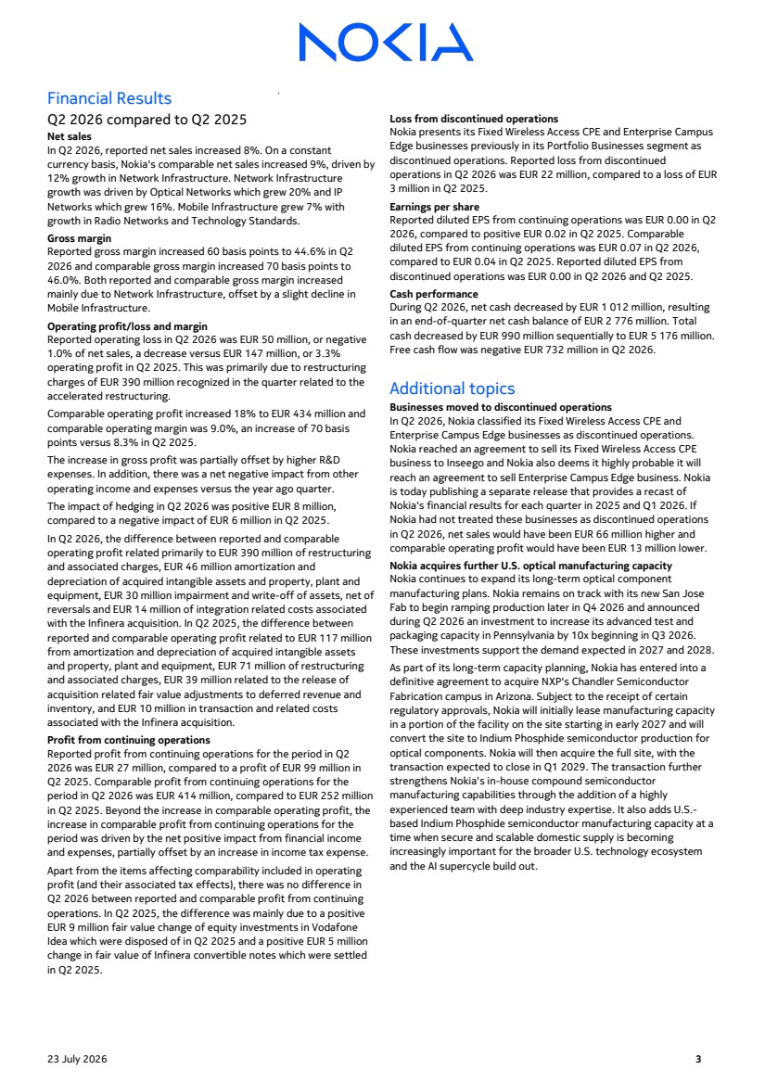 | Financial Results Q2 2026 compared to Q2 2025 Net sales In Q2 2026, reported net sales increased 8%. On a constant currency basis, Nokia's comparable net sales increased 9%, driven by 12% growth in Network Infrastructure. Network Infrastructure growth was driven by Optical Networks which grew 20% and IP Networks which grew 16%. Mobile Infrastructure grew 7% with growth in Radio Networks and Technology Standards. Gross margin Reported gross margin increased 60 basis points to 44.6% in Q2 2026 and comparable gross margin increased 70 basis points to 46.0%. Both reported and comparable gross margin increased mainly due to Network Infrastructure, offset by a slight decline in Mobile Infrastructure. Operating profit/loss and margin Reported operating loss in Q2 2026 was EUR 50 million, or negative 1.0% of net sales, a decrease versus EUR 147 million, or 3.3% operating profit in Q2 2025. This was primarily due to restructuring charges of EUR 390 million recognized in the quarter related to the accelerated restructuring. Comparable operating profit increased 18% to EUR 434 million and comparable operating margin was 9.0%, an increase of 70 basis points versus 8.3% in Q2 2025. The increase in gross profit was partially offset by higher R&D expenses. In addition, there was a net negative impact from other operating income and expenses versus the year ago quarter. The impact of hedging in Q2 2026 was positive EUR 8 million, compared to a negative impact of EUR 6 million in Q2 2025. In Q2 2026, the difference between reported and comparable operating profit related primarily to EUR 390 million of restructuring and associated charges, EUR 46 million amortization and depreciation of acquired intangible assets and property, plant and equipment, EUR 30 million impairment and write-off of assets, net of reversals and EUR 14 million of integration related costs associated with the Infinera acquisition. In Q2 2025, the difference between reported and comparable operating profit related to EUR 117 million from amortization and depreciation of acquired intangible assets and property, plant and equipment, EUR 71 million of restructuring and associated charges, EUR 39 million related to the release of acquisition related fair value adjustments to deferred revenue and inventory, and EUR 10 million in transaction and related costs associated with the Infinera acquisition. Profit from continuing operations Reported profit from continuing operations for the period in Q2 2026 was EUR 27 million, compared to a profit of EUR 99 million in Q2 2025. Comparable profit from continuing operations for the period in Q2 2026 was EUR 414 million, compared to EUR 252 million in Q2 2025. Beyond the increase in comparable operating profit, the increase in comparable profit from continuing operations for the period was driven by the net positive impact from financial income and expenses, partially offset by an increase in income tax expense. Apart from the items affecting comparability included in operating profit (and their associated tax effects), there was no difference in Q2 2026 between reported and comparable profit from continuing operations. In Q2 2025, the difference was mainly due to a positive EUR 9 million fair value change of equity investments in Vodafone Idea which were disposed of in Q2 2025 and a positive EUR 5 million change in fair value of Infinera convertible notes which were settled in Q2 2025. Loss from discontinued operations Nokia presents its Fixed Wireless Access CPE and Enterprise Campus Edge businesses previously in its Portfolio Businesses segment as discontinued operations. Reported loss from discontinued operations in Q2 2026 was EUR 22 million, compared to a loss of EUR 3 million in Q2 2025. Earnings per share Reported diluted EPS from continuing operations was EUR 0.00 in Q2 2026, compared to positive EUR 0.02 in Q2 2025. Comparable diluted EPS from continuing operations was EUR 0.07 in Q2 2026, compared to EUR 0.04 in Q2 2025. Reported diluted EPS from discontinued operations was EUR 0.00 in Q2 2026 and Q2 2025. Cash performance During Q2 2026, net cash decreased by EUR 1 012 million, resulting in an end-of-quarter net cash balance of EUR 2 776 million. Total cash decreased by EUR 990 million sequentially to EUR 5 176 million. Free cash flow was negative EUR 732 million in Q2 2026. Additional topics Businesses moved to discontinued operations In Q2 2026, Nokia classified its Fixed Wireless Access CPE and Enterprise Campus Edge businesses as discontinued operations. Nokia reached an agreement to sell its Fixed Wireless Access CPE business to Inseego and Nokia also deems it highly probable it will reach an agreement to sell Enterprise Campus Edge business. Nokia is today publishing a separate release that provides a recast of Nokia's financial results for each quarter in 2025 and Q1 2026. If Nokia had not treated these businesses as discontinued operations in Q2 2026, net sales would have been EUR 66 million higher and comparable operating profit would have been EUR 13 million lower. Nokia acquires further U.S. optical manufacturing capacity Nokia continues to expand its long-term optical component manufacturing plans. Nokia remains on track with its new San Jose Fab to begin ramping production later in Q4 2026 and announced during Q2 2026 an investment to increase its advanced test and packaging capacity in Pennsylvania by 10x beginning in Q3 2026. These investments support the demand expected in 2027 and 2028. As part of its long-term capacity planning, Nokia has entered into a definitive agreement to acquire NXP's Chandler Semiconductor Fabrication campus in Arizona. Subject to the receipt of certain regulatory approvals, Nokia will initially lease manufacturing capacity in a portion of the facility on the site starting in early 2027 and will convert the site to Indium Phosphide semiconductor production for optical components. Nokia will then acquire the full site, with the transaction expected to close in Q1 2029. The transaction further strengthens Nokia's in-house compound semiconductor manufacturing capabilities through the addition of a highly experienced team with deep industry expertise. It also adds U.S.- based Indium Phosphide semiconductor manufacturing capacity at a time when secure and scalable domestic supply is becoming increasingly important for the broader U.S. technology ecosystem and the AI supercycle build out. 23 July 2026 3
 | 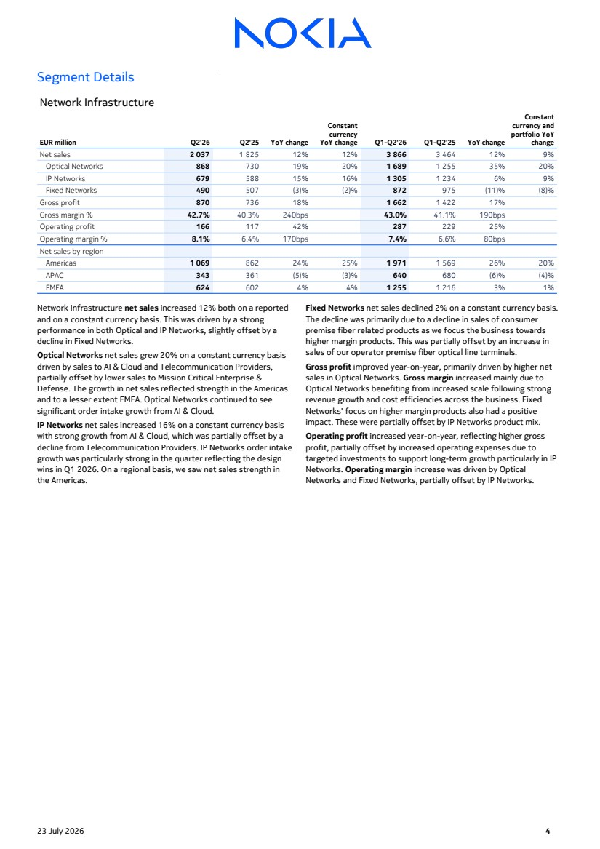 | Segment Details Network Infrastructure EUR million Q2'26 Q2'25 YoY change Constant currency YoY change Q1-Q2'26 Q1-Q2'25 YoY change Constant currency and portfolio YoY change Net sales 2 037 1 825 12% 12% 3 866 3 464 12% 9% Optical Networks 868 730 19% 20% 1 689 1 255 35% 20% IP Networks 679 588 15% 16% 1 305 1 234 6% 9% Fixed Networks 490 507 (3)% (2)% 872 975 (11)% (8)% Gross profit 870 736 18% 1 662 1 422 17% Gross margin % 42.7% 40.3% 240bps 43.0% 41.1% 190bps Operating profit 166 117 42% 287 229 25% Operating margin % 8.1% 6.4% 170bps 7.4% 6.6% 80bps Net sales by region Americas 1 069 862 24% 25% 1 971 1 569 26% 20% APAC 343 361 (5)% (3)% 640 680 (6)% (4)% EMEA 624 602 4% 4% 1 255 1 216 3% 1% Network Infrastructure net sales increased 12% both on a reported and on a constant currency basis. This was driven by a strong performance in both Optical and IP Networks, slightly offset by a decline in Fixed Networks. Optical Networks net sales grew 20% on a constant currency basis driven by sales to AI & Cloud and Telecommunication Providers, partially offset by lower sales to Mission Critical Enterprise & Defense. The growth in net sales reflected strength in the Americas and to a lesser extent EMEA. Optical Networks continued to see significant order intake growth from AI & Cloud. IP Networks net sales increased 16% on a constant currency basis with strong growth from AI & Cloud, which was partially offset by a decline from Telecommunication Providers. IP Networks order intake growth was particularly strong in the quarter reflecting the design wins in Q1 2026. On a regional basis, we saw net sales strength in the Americas. Fixed Networks net sales declined 2% on a constant currency basis. The decline was primarily due to a decline in sales of consumer premise fiber related products as we focus the business towards higher margin products. This was partially offset by an increase in sales of our operator premise fiber optical line terminals. Gross profit improved year-on-year, primarily driven by higher net sales in Optical Networks. Gross margin increased mainly due to Optical Networks benefiting from increased scale following strong revenue growth and cost efficiencies across the business. Fixed Networks' focus on higher margin products also had a positive impact. These were partially offset by IP Networks product mix. Operating profit increased year-on-year, reflecting higher gross profit, partially offset by increased operating expenses due to targeted investments to support long-term growth particularly in IP Networks. Operating margin increase was driven by Optical Networks and Fixed Networks, partially offset by IP Networks. 23 July 2026 4
 | 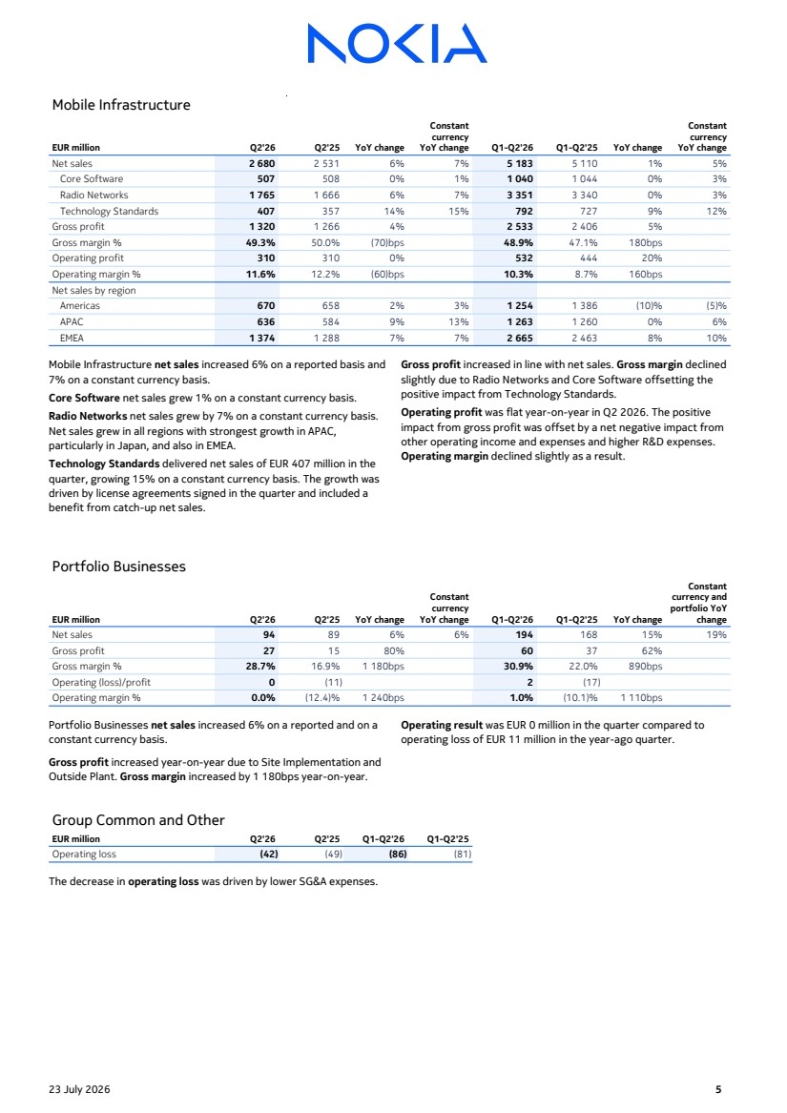 | Mobile Infrastructure EUR million Q2'26 Q2'25 YoY change Constant currency YoY change Q1-Q2'26 Q1-Q2'25 YoY change Constant currency YoY change Net sales 2 680 2 531 6% 7% 5 183 5 110 1% 5% Core Software 507 508 0% 1% 1 040 1 044 0% 3% Radio Networks 1 765 1 666 6% 7% 3 351 3 340 0% 3% Technology Standards 407 357 14% 15% 792 727 9% 12% Gross profit 1 320 1 266 4% 2 533 2 406 5% Gross margin % 49.3% 50.0% (70)bps 48.9% 47.1% 180bps Operating profit 310 310 0% 532 444 20% Operating margin % 11.6% 12.2% (60)bps 10.3% 8.7% 160bps Net sales by region Americas 670 658 2% 3% 1 254 1 386 (10)% (5)% APAC 636 584 9% 13% 1 263 1 260 0% 6% EMEA 1 374 1 288 7% 7% 2 665 2 463 8% 10% Mobile Infrastructure net sales increased 6% on a reported basis and 7% on a constant currency basis. Core Software net sales grew 1% on a constant currency basis. Radio Networks net sales grew by 7% on a constant currency basis. Net sales grew in all regions with strongest growth in APAC, particularly in Japan, and also in EMEA. Technology Standards delivered net sales of EUR 407 million in the quarter, growing 15% on a constant currency basis. The growth was driven by license agreements signed in the quarter and included a benefit from catch-up net sales. Gross profit increased in line with net sales. Gross margin declined slightly due to Radio Networks and Core Software offsetting the positive impact from Technology Standards. Operating profit was flat year-on-year in Q2 2026. The positive impact from gross profit was offset by a net negative impact from other operating income and expenses and higher R&D expenses. Operating margin declined slightly as a result. Portfolio Businesses EUR million Q2'26 Q2'25 YoY change Constant currency YoY change Q1-Q2'26 Q1-Q2'25 YoY change Constant currency and portfolio YoY change Net sales 94 89 6% 6% 194 168 15% 19% Gross profit 27 15 80% 60 37 62% Gross margin % 28.7% 16.9% 1 180bps 30.9% 22.0% 890bps Operating (loss)/profit 0 (11) 2 (17) Operating margin % 0.0% (12.4)% 1 240bps 1.0% (10.1)% 1 110bps Portfolio Businesses net sales increased 6% on a reported and on a constant currency basis. Gross profit increased year-on-year due to Site Implementation and Outside Plant. Gross margin increased by 1 180bps year-on-year. Operating result was EUR 0 million in the quarter compared to operating loss of EUR 11 million in the year-ago quarter. Group Common and Other EUR million Q2'26 Q2'25 Q1-Q2'26 Q1-Q2'25 Operating loss (42) (49) (86) (81) The decrease in operating loss was driven by lower SG&A expenses. 23 July 2026 5
 | 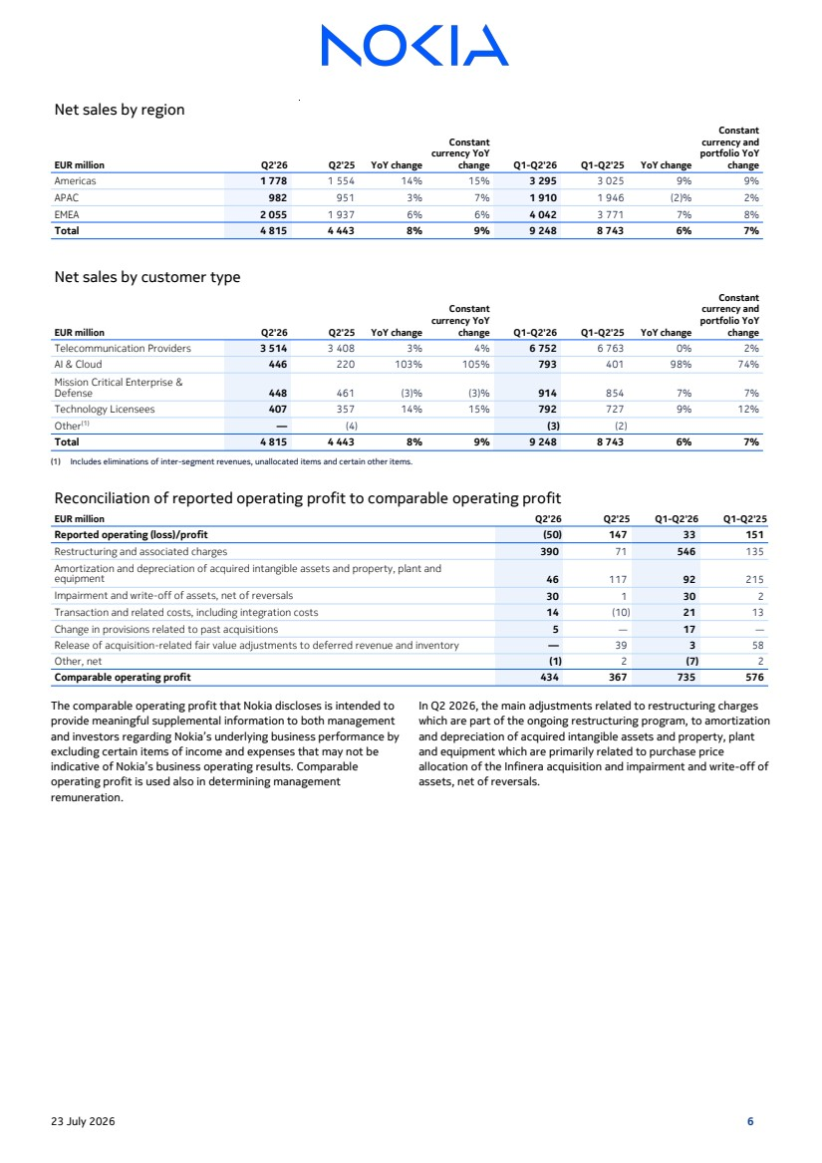 | Net sales by region EUR million Q2'26 Q2'25 YoY change Constant currency YoY change Q1-Q2'26 Q1-Q2'25 YoY change Constant currency and portfolio YoY change Americas 1 778 1 554 14% 15% 3 295 3 025 9% 9% APAC 982 951 3% 7% 1 910 1 946 (2)% 2% EMEA 2 055 1 937 6% 6% 4 042 3 771 7% 8% Total 4 815 4 443 8% 9% 9 248 8 743 6% 7% Net sales by customer type EUR million Q2'26 Q2'25 YoY change Constant currency YoY change Q1-Q2'26 Q1-Q2'25 YoY change Constant currency and portfolio YoY change Telecommunication Providers 3 514 3 408 3% 4% 6 752 6 763 0% 2% AI & Cloud 446 220 103% 105% 793 401 98% 74% Mission Critical Enterprise & Defense 448 461 (3)% (3)% 914 854 7% 7% Technology Licensees 407 357 14% 15% 792 727 9% 12% Other(1) — (4) (3) (2) Total 4 815 4 443 8% 9% 9 248 8 743 6% 7% (1) Includes eliminations of inter-segment revenues, unallocated items and certain other items. Reconciliation of reported operating profit to comparable operating profit EUR million Q2'26 Q2'25 Q1-Q2'26 Q1-Q2'25 Reported operating (loss)/profit (50) 147 33 151 Restructuring and associated charges 390 71 546 135 Amortization and depreciation of acquired intangible assets and property, plant and equipment 46 117 92 215 Impairment and write-off of assets, net of reversals 30 1 30 2 Transaction and related costs, including integration costs 14 (10) 21 13 Change in provisions related to past acquisitions 5 — 17 — Release of acquisition-related fair value adjustments to deferred revenue and inventory — 39 3 58 Other, net (1) 2 (7) 2 Comparable operating profit 434 367 735 576 The comparable operating profit that Nokia discloses is intended to provide meaningful supplemental information to both management and investors regarding Nokia’s underlying business performance by excluding certain items of income and expenses that may not be indicative of Nokia’s business operating results. Comparable operating profit is used also in determining management remuneration. In Q2 2026, the main adjustments related to restructuring charges which are part of the ongoing restructuring program, to amortization and depreciation of acquired intangible assets and property, plant and equipment which are primarily related to purchase price allocation of the Infinera acquisition and impairment and write-off of assets, net of reversals. 23 July 2026 6
 | 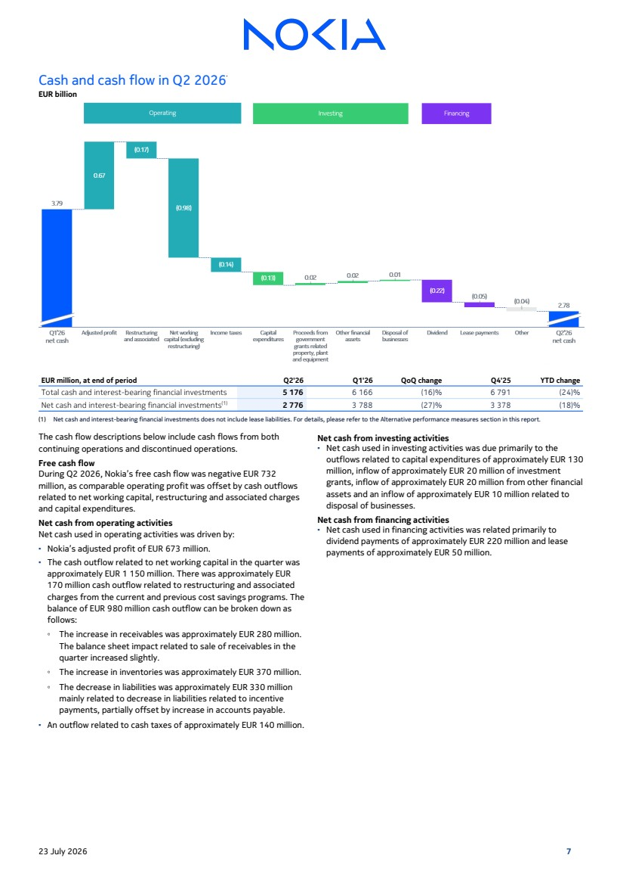 | Cash and cash flow in Q2 2026 EUR billion EUR million, at end of period Q2'26 Q1'26 QoQ change Q4'25 YTD change Total cash and interest-bearing financial investments 5 176 6 166 (16)% 6 791 (24)% Net cash and interest-bearing financial investments(1) 2 776 3 788 (27)% 3 378 (18)% (1) Net cash and interest-bearing financial investments does not include lease liabilities. For details, please refer to the Alternative performance measures section in this report. The cash flow descriptions below include cash flows from both continuing operations and discontinued operations. Free cash flow During Q2 2026, Nokia’s free cash flow was negative EUR 732 million, as comparable operating profit was offset by cash outflows related to net working capital, restructuring and associated charges and capital expenditures. Net cash from operating activities Net cash used in operating activities was driven by: ▪ Nokia’s adjusted profit of EUR 673 million. ▪ The cash outflow related to net working capital in the quarter was approximately EUR 1 150 million. There was approximately EUR 170 million cash outflow related to restructuring and associated charges from the current and previous cost savings programs. The balance of EUR 980 million cash outflow can be broken down as follows: ◦ The increase in receivables was approximately EUR 280 million. The balance sheet impact related to sale of receivables in the quarter increased slightly. ◦ The increase in inventories was approximately EUR 370 million. ◦ The decrease in liabilities was approximately EUR 330 million mainly related to decrease in liabilities related to incentive payments, partially offset by increase in accounts payable. ▪ An outflow related to cash taxes of approximately EUR 140 million. Net cash from investing activities ▪ Net cash used in investing activities was due primarily to the outflows related to capital expenditures of approximately EUR 130 million, inflow of approximately EUR 20 million of investment grants, inflow of approximately EUR 20 million from other financial assets and an inflow of approximately EUR 10 million related to disposal of businesses. Net cash from financing activities ▪ Net cash used in financing activities was related primarily to dividend payments of approximately EUR 220 million and lease payments of approximately EUR 50 million. 23 July 2026 7
 | 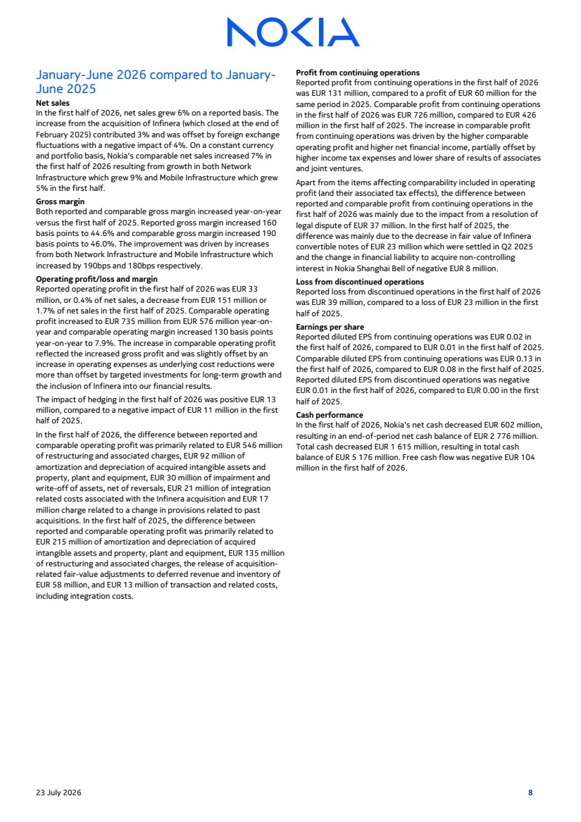 | January-June 2026 compared to January-June 2025 Net sales In the first half of 2026, net sales grew 6% on a reported basis. The increase from the acquisition of Infinera (which closed at the end of February 2025) contributed 3% and was offset by foreign exchange fluctuations with a negative impact of 4%. On a constant currency and portfolio basis, Nokia's comparable net sales increased 7% in the first half of 2026 resulting from growth in both Network Infrastructure which grew 9% and Mobile Infrastructure which grew 5% in the first half. Gross margin Both reported and comparable gross margin increased year-on-year versus the first half of 2025. Reported gross margin increased 160 basis points to 44.6% and comparable gross margin increased 190 basis points to 46.0%. The improvement was driven by increases from both Network Infrastructure and Mobile Infrastructure which increased by 190bps and 180bps respectively. Operating profit/loss and margin Reported operating profit in the first half of 2026 was EUR 33 million, or 0.4% of net sales, a decrease from EUR 151 million or 1.7% of net sales in the first half of 2025. Comparable operating profit increased to EUR 735 million from EUR 576 million year-on-year and comparable operating margin increased 130 basis points year-on-year to 7.9%. The increase in comparable operating profit reflected the increased gross profit and was slightly offset by an increase in operating expenses as underlying cost reductions were more than offset by targeted investments for long-term growth and the inclusion of Infinera into our financial results. The impact of hedging in the first half of 2026 was positive EUR 13 million, compared to a negative impact of EUR 11 million in the first half of 2025. In the first half of 2026, the difference between reported and comparable operating profit was primarily related to EUR 546 million of restructuring and associated charges, EUR 92 million of amortization and depreciation of acquired intangible assets and property, plant and equipment, EUR 30 million of impairment and write-off of assets, net of reversals, EUR 21 million of integration related costs associated with the Infinera acquisition and EUR 17 million charge related to a change in provisions related to past acquisitions. In the first half of 2025, the difference between reported and comparable operating profit was primarily related to EUR 215 million of amortization and depreciation of acquired intangible assets and property, plant and equipment, EUR 135 million of restructuring and associated charges, the release of acquisition-related fair-value adjustments to deferred revenue and inventory of EUR 58 million, and EUR 13 million of transaction and related costs, including integration costs. Profit from continuing operations Reported profit from continuing operations in the first half of 2026 was EUR 131 million, compared to a profit of EUR 60 million for the same period in 2025. Comparable profit from continuing operations in the first half of 2026 was EUR 726 million, compared to EUR 426 million in the first half of 2025. The increase in comparable profit from continuing operations was driven by the higher comparable operating profit and higher net financial income, partially offset by higher income tax expenses and lower share of results of associates and joint ventures. Apart from the items affecting comparability included in operating profit (and their associated tax effects), the difference between reported and comparable profit from continuing operations in the first half of 2026 was mainly due to the impact from a resolution of legal dispute of EUR 37 million. In the first half of 2025, the difference was mainly due to the decrease in fair value of Infinera convertible notes of EUR 23 million which were settled in Q2 2025 and the change in financial liability to acquire non-controlling interest in Nokia Shanghai Bell of negative EUR 8 million. Loss from discontinued operations Reported loss from discontinued operations in the first half of 2026 was EUR 39 million, compared to a loss of EUR 23 million in the first half of 2025. Earnings per share Reported diluted EPS from continuing operations was EUR 0.02 in the first half of 2026, compared to EUR 0.01 in the first half of 2025. Comparable diluted EPS from continuing operations was EUR 0.13 in the first half of 2026, compared to EUR 0.08 in the first half of 2025. Reported diluted EPS from discontinued operations was negative EUR 0.01 in the first half of 2026, compared to EUR 0.00 in the first half of 2025. Cash performance In the first half of 2026, Nokia's net cash decreased EUR 602 million, resulting in an end-of-period net cash balance of EUR 2 776 million. Total cash decreased EUR 1 615 million, resulting in total cash balance of EUR 5 176 million. Free cash flow was negative EUR 104 million in the first half of 2026. 23 July 2026 8
 | 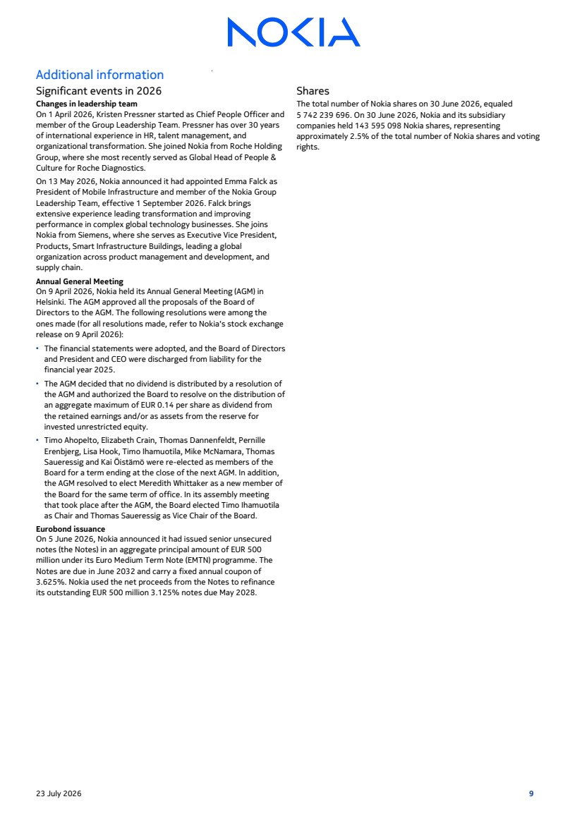 | Additional information Significant events in 2026 Changes in leadership team On 1 April 2026, Kristen Pressner started as Chief People Officer and member of the Group Leadership Team. Pressner has over 30 years of international experience in HR, talent management, and organizational transformation. She joined Nokia from Roche Holding Group, where she most recently served as Global Head of People & Culture for Roche Diagnostics. On 13 May 2026, Nokia announced it had appointed Emma Falck as President of Mobile Infrastructure and member of the Nokia Group Leadership Team, effective 1 September 2026. Falck brings extensive experience leading transformation and improving performance in complex global technology businesses. She joins Nokia from Siemens, where she serves as Executive Vice President, Products, Smart Infrastructure Buildings, leading a global organization across product management and development, and supply chain. Annual General Meeting On 9 April 2026, Nokia held its Annual General Meeting (AGM) in Helsinki. The AGM approved all the proposals of the Board of Directors to the AGM. The following resolutions were among the ones made (for all resolutions made, refer to Nokia's stock exchange release on 9 April 2026): ▪ The financial statements were adopted, and the Board of Directors and President and CEO were discharged from liability for the financial year 2025. ▪ The AGM decided that no dividend is distributed by a resolution of the AGM and authorized the Board to resolve on the distribution of an aggregate maximum of EUR 0.14 per share as dividend from the retained earnings and/or as assets from the reserve for invested unrestricted equity. ▪ Timo Ahopelto, Elizabeth Crain, Thomas Dannenfeldt, Pernille Erenbjerg, Lisa Hook, Timo Ihamuotila, Mike McNamara, Thomas Saueressig and Kai Öistämö were re-elected as members of the Board for a term ending at the close of the next AGM. In addition, the AGM resolved to elect Meredith Whittaker as a new member of the Board for the same term of office. In its assembly meeting that took place after the AGM, the Board elected Timo Ihamuotila as Chair and Thomas Saueressig as Vice Chair of the Board. Eurobond issuance On 5 June 2026, Nokia announced it had issued senior unsecured notes (the Notes) in an aggregate principal amount of EUR 500 million under its Euro Medium Term Note (EMTN) programme. The Notes are due in June 2032 and carry a fixed annual coupon of 3.625%. Nokia used the net proceeds from the Notes to refinance its outstanding EUR 500 million 3.125% notes due May 2028. Shares The total number of Nokia shares on 30 June 2026, equaled 5 742 239 696. On 30 June 2026, Nokia and its subsidiary companies held 143 595 098 Nokia shares, representing approximately 2.5% of the total number of Nokia shares and voting rights. 23 July 2026 9
 | 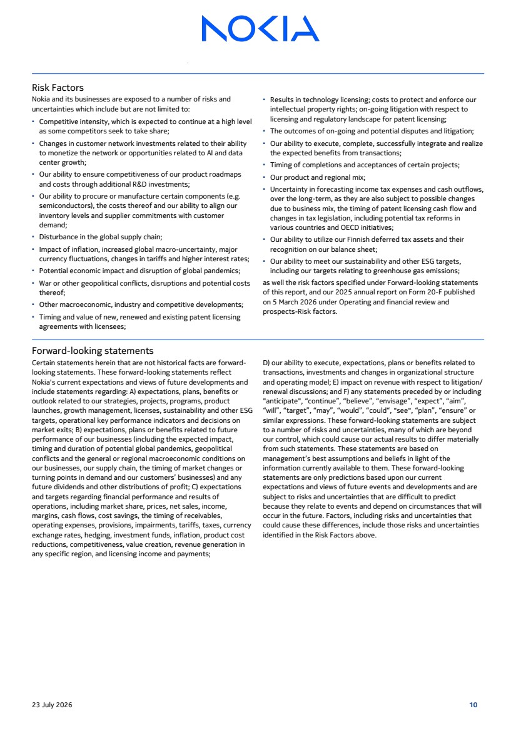 | Risk Factors Nokia and its businesses are exposed to a number of risks and uncertainties which include but are not limited to: ▪ Competitive intensity, which is expected to continue at a high level as some competitors seek to take share; ▪ Changes in customer network investments related to their ability to monetize the network or opportunities related to AI and data center growth; ▪ Our ability to ensure competitiveness of our product roadmaps and costs through additional R&D investments; ▪ Our ability to procure or manufacture certain components (e.g. semiconductors), the costs thereof and our ability to align our inventory levels and supplier commitments with customer demand; ▪ Disturbance in the global supply chain; ▪ Impact of inflation, increased global macro-uncertainty, major currency fluctuations, changes in tariffs and higher interest rates; ▪ Potential economic impact and disruption of global pandemics; ▪ War or other geopolitical conflicts, disruptions and potential costs thereof; ▪ Other macroeconomic, industry and competitive developments; ▪ Timing and value of new, renewed and existing patent licensing agreements with licensees; ▪ Results in technology licensing; costs to protect and enforce our intellectual property rights; on-going litigation with respect to licensing and regulatory landscape for patent licensing; ▪ The outcomes of on-going and potential disputes and litigation; ▪ Our ability to execute, complete, successfully integrate and realize the expected benefits from transactions; ▪ Timing of completions and acceptances of certain projects; ▪ Our product and regional mix; ▪ Uncertainty in forecasting income tax expenses and cash outflows, over the long-term, as they are also subject to possible changes due to business mix, the timing of patent licensing cash flow and changes in tax legislation, including potential tax reforms in various countries and OECD initiatives; ▪ Our ability to utilize our Finnish deferred tax assets and their recognition on our balance sheet; ▪ Our ability to meet our sustainability and other ESG targets, including our targets relating to greenhouse gas emissions; as well the risk factors specified under Forward-looking statements of this report, and our 2025 annual report on Form 20-F published on 5 March 2026 under Operating and financial review and prospects-Risk factors. Forward-looking statements Certain statements herein that are not historical facts are forward-looking statements. These forward-looking statements reflect Nokia's current expectations and views of future developments and include statements regarding: A) expectations, plans, benefits or outlook related to our strategies, projects, programs, product launches, growth management, licenses, sustainability and other ESG targets, operational key performance indicators and decisions on market exits; B) expectations, plans or benefits related to future performance of our businesses (including the expected impact, timing and duration of potential global pandemics, geopolitical conflicts and the general or regional macroeconomic conditions on our businesses, our supply chain, the timing of market changes or turning points in demand and our customers’ businesses) and any future dividends and other distributions of profit; C) expectations and targets regarding financial performance and results of operations, including market share, prices, net sales, income, margins, cash flows, cost savings, the timing of receivables, operating expenses, provisions, impairments, tariffs, taxes, currency exchange rates, hedging, investment funds, inflation, product cost reductions, competitiveness, value creation, revenue generation in any specific region, and licensing income and payments; D) our ability to execute, expectations, plans or benefits related to transactions, investments and changes in organizational structure and operating model; E) impact on revenue with respect to litigation/ renewal discussions; and F) any statements preceded by or including "anticipate", “continue”, “believe”, “envisage”, “expect”, “aim”, “will”, “target”, “may”, “would”, “could“, "see", “plan”, “ensure” or similar expressions. These forward-looking statements are subject to a number of risks and uncertainties, many of which are beyond our control, which could cause our actual results to differ materially from such statements. These statements are based on management’s best assumptions and beliefs in light of the information currently available to them. These forward-looking statements are only predictions based upon our current expectations and views of future events and developments and are subject to risks and uncertainties that are difficult to predict because they relate to events and depend on circumstances that will occur in the future. Factors, including risks and uncertainties that could cause these differences, include those risks and uncertainties identified in the Risk Factors above. 23 July 2026 10
 | 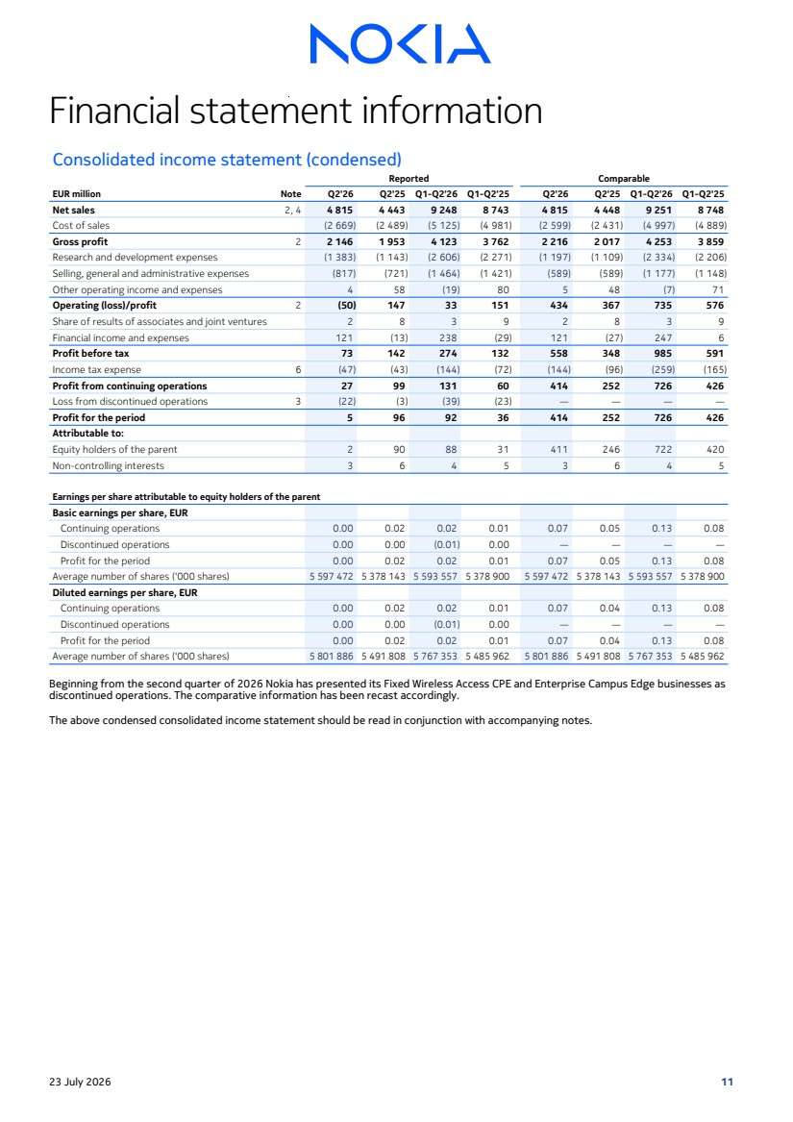 | Financial statement information Consolidated income statement (condensed) EUR million Reported Comparable Note Q2'26 Q2'25 Q1-Q2'26 Q1-Q2'25 Q2'26 Q2'25 Q1-Q2'26 Q1-Q2'25 Net sales 2, 4 4 815 4 443 9 248 8 743 4 815 4 448 9 251 8 748 Cost of sales (2 669) (2 489) (5 125) (4 981) (2 599) (2 431) (4 997) (4 889) Gross profit 2 2 146 1 953 4 123 3 762 2 216 2 017 4 253 3 859 Research and development expenses (1 383) (1 143) (2 606) (2 271) (1 197) (1 109) (2 334) (2 206) Selling, general and administrative expenses (817) (721) (1 464) (1 421) (589) (589) (1 177) (1 148) Other operating income and expenses 4 58 (19) 80 5 48 (7) 71 Operating (loss)/profit 2 (50) 147 33 151 434 367 735 576 Share of results of associates and joint ventures 2 8 3 9 2 8 3 9 Financial income and expenses 121 (13) 238 (29) 121 (27) 247 6 Profit before tax 73 142 274 132 558 348 985 591 Income tax expense 6 (47) (43) (144) (72) (144) (96) (259) (165) Profit from continuing operations 27 99 131 60 414 252 726 426 Loss from discontinued operations 3 (22) (3) (39) (23) — — — — Profit for the period 5 96 92 36 414 252 726 426 Attributable to: Equity holders of the parent 2 90 88 31 411 246 722 420 Non-controlling interests 3 6 4 5 3 6 4 5 Earnings per share attributable to equity holders of the parent Basic earnings per share, EUR Continuing operations 0.00 0.02 0.02 0.01 0.07 0.05 0.13 0.08 Discontinued operations 0.00 0.00 (0.01) 0.00 — — — — Profit for the period 0.00 0.02 0.02 0.01 0.07 0.05 0.13 0.08 Average number of shares ('000 shares) 5 597 472 5 378 143 5 593 557 5 378 900 5 597 472 5 378 143 5 593 557 5 378 900 Diluted earnings per share, EUR Continuing operations 0.00 0.02 0.02 0.01 0.07 0.04 0.13 0.08 Discontinued operations 0.00 0.00 (0.01) 0.00 — — — — Profit for the period 0.00 0.02 0.02 0.01 0.07 0.04 0.13 0.08 Average number of shares ('000 shares) 5 801 886 5 491 808 5 767 353 5 485 962 5 801 886 5 491 808 5 767 353 5 485 962 Beginning from the second quarter of 2026 Nokia has presented its Fixed Wireless Access CPE and Enterprise Campus Edge businesses as discontinued operations. The comparative information has been recast accordingly. The above condensed consolidated income statement should be read in conjunction with accompanying notes. 23 July 2026 11
 | 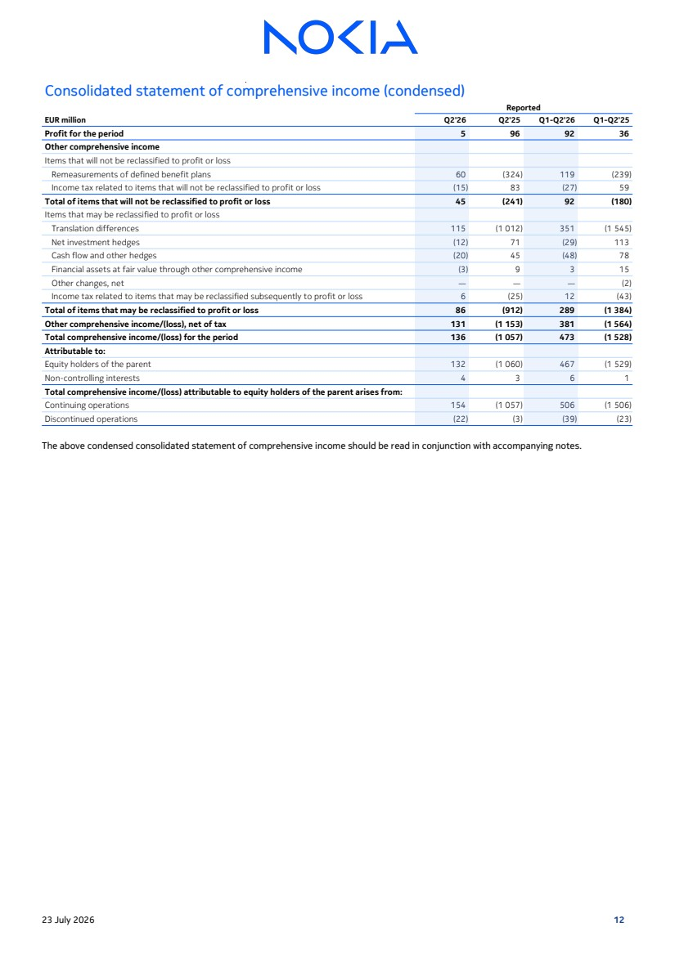 | Consolidated statement of comprehensive income (condensed) EUR million Reported Q2'26 Q2'25 Q1-Q2'26 Q1-Q2'25 Profit for the period 5 96 92 36 Other comprehensive income Items that will not be reclassified to profit or loss Remeasurements of defined benefit plans 60 (324) 119 (239) Income tax related to items that will not be reclassified to profit or loss (15) 83 (27) 59 Total of items that will not be reclassified to profit or loss 45 (241) 92 (180) Items that may be reclassified to profit or loss Translation differences 115 (1 012) 351 (1 545) Net investment hedges (12) 71 (29) 113 Cash flow and other hedges (20) 45 (48) 78 Financial assets at fair value through other comprehensive income (3) 9 3 15 Other changes, net — — — (2) Income tax related to items that may be reclassified subsequently to profit or loss 6 (25) 12 (43) Total of items that may be reclassified to profit or loss 86 (912) 289 (1 384) Other comprehensive income/(loss), net of tax 131 (1 153) 381 (1 564) Total comprehensive income/(loss) for the period 136 (1 057) 473 (1 528) Attributable to: Equity holders of the parent 132 (1 060) 467 (1 529) Non-controlling interests 4 3 6 1 Total comprehensive income/(loss) attributable to equity holders of the parent arises from: Continuing operations 154 (1 057) 506 (1 506) Discontinued operations (22) (3) (39) (23) The above condensed consolidated statement of comprehensive income should be read in conjunction with accompanying notes. 23 July 2026 12
 | 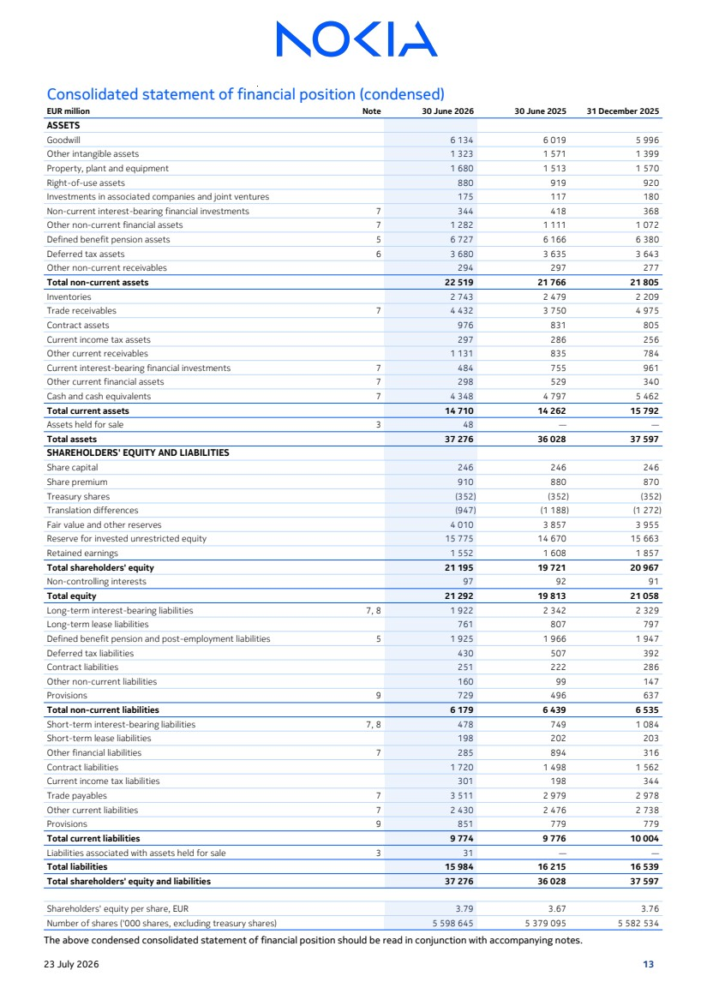 | Consolidated statement of financial position (condensed) EUR million Note 30 June 2026 30 June 2025 31 December 2025 ASSETS Goodwill 6 134 6 019 5 996 Other intangible assets 1 323 1 571 1 399 Property, plant and equipment 1 680 1 513 1 570 Right-of-use assets 880 919 920 Investments in associated companies and joint ventures 175 117 180 Non-current interest-bearing financial investments 7 344 418 368 Other non-current financial assets 7 1 282 1 111 1 072 Defined benefit pension assets 5 6 727 6 166 6 380 Deferred tax assets 6 3 680 3 635 3 643 Other non-current receivables 294 297 277 Total non-current assets 22 519 21 766 21 805 Inventories 2 743 2 479 2 209 Trade receivables 7 4 432 3 750 4 975 Contract assets 976 831 805 Current income tax assets 297 286 256 Other current receivables 1 131 835 784 Current interest-bearing financial investments 7 484 755 961 Other current financial assets 7 298 529 340 Cash and cash equivalents 7 4 348 4 797 5 462 Total current assets 14 710 14 262 15 792 Assets held for sale 3 48 — — Total assets 37 276 36 028 37 597 SHAREHOLDERS' EQUITY AND LIABILITIES Share capital 246 246 246 Share premium 910 880 870 Treasury shares (352) (352) (352) Translation differences (947) (1 188) (1 272) Fair value and other reserves 4 010 3 857 3 955 Reserve for invested unrestricted equity 15 775 14 670 15 663 Retained earnings 1 552 1 608 1 857 Total shareholders' equity 21 195 19 721 20 967 Non-controlling interests 97 92 91 Total equity 21 292 19 813 21 058 Long-term interest-bearing liabilities 7, 8 1 922 2 342 2 329 Long-term lease liabilities 761 807 797 Defined benefit pension and post-employment liabilities 5 1 925 1 966 1 947 Deferred tax liabilities 430 507 392 Contract liabilities 251 222 286 Other non-current liabilities 160 99 147 Provisions 9 729 496 637 Total non-current liabilities 6 179 6 439 6 535 Short-term interest-bearing liabilities 7, 8 478 749 1 084 Short-term lease liabilities 198 202 203 Other financial liabilities 7 285 894 316 Contract liabilities 1 720 1 498 1 562 Current income tax liabilities 301 198 344 Trade payables 7 3 511 2 979 2 978 Other current liabilities 7 2 430 2 476 2 738 Provisions 9 851 779 779 Total current liabilities 9 774 9 776 10 004 Liabilities associated with assets held for sale 3 31 — — Total liabilities 15 984 16 215 16 539 Total shareholders' equity and liabilities 37 276 36 028 37 597 Shareholders' equity per share, EUR 3.79 3.67 3.76 Number of shares ('000 shares, excluding treasury shares) 5 598 645 5 379 095 5 582 534 The above condensed consolidated statement of financial position should be read in conjunction with accompanying notes. 23 July 2026 13
 | 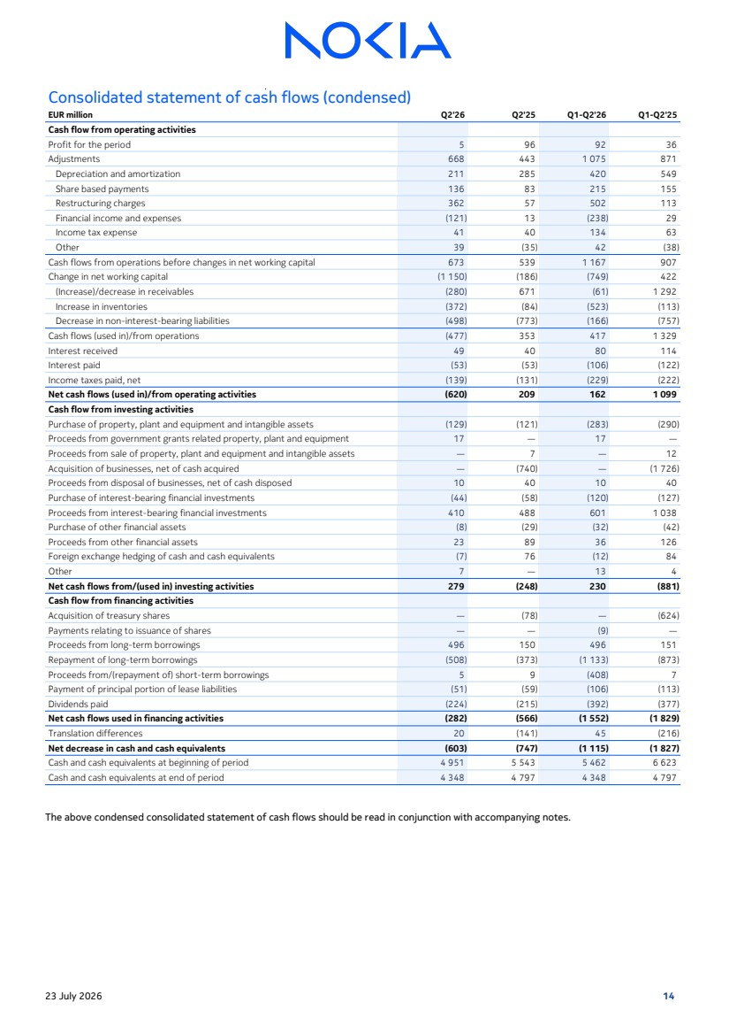 | Consolidated statement of cash flows (condensed) EUR million Q2'26 Q2'25 Q1-Q2'26 Q1-Q2'25 Cash flow from operating activities Profit for the period 5 96 92 36 Adjustments 668 443 1 075 871 Depreciation and amortization 211 285 420 549 Share based payments 136 83 215 155 Restructuring charges 362 57 502 113 Financial income and expenses (121) 13 (238) 29 Income tax expense 41 40 134 63 Other 39 (35) 42 (38) Cash flows from operations before changes in net working capital 673 539 1 167 907 Change in net working capital (1 150) (186) (749) 422 (Increase)/decrease in receivables (280) 671 (61) 1 292 Increase in inventories (372) (84) (523) (113) Decrease in non-interest-bearing liabilities (498) (773) (166) (757) Cash flows (used in)/from operations (477) 353 417 1 329 Interest received 49 40 80 114 Interest paid (53) (53) (106) (122) Income taxes paid, net (139) (131) (229) (222) Net cash flows (used in)/from operating activities (620) 209 162 1 099 Cash flow from investing activities Purchase of property, plant and equipment and intangible assets (129) (121) (283) (290) Proceeds from government grants related property, plant and equipment 17 — 17 — Proceeds from sale of property, plant and equipment and intangible assets — 7 — 12 Acquisition of businesses, net of cash acquired — (740) — (1 726) Proceeds from disposal of businesses, net of cash disposed 10 40 10 40 Purchase of interest-bearing financial investments (44) (58) (120) (127) Proceeds from interest-bearing financial investments 410 488 601 1 038 Purchase of other financial assets (8) (29) (32) (42) Proceeds from other financial assets 23 89 36 126 Foreign exchange hedging of cash and cash equivalents (7) 76 (12) 84 Other 7 — 13 4 Net cash flows from/(used in) investing activities 279 (248) 230 (881) Cash flow from financing activities Acquisition of treasury shares — (78) — (624) Payments relating to issuance of shares — — (9) — Proceeds from long-term borrowings 496 150 496 151 Repayment of long-term borrowings (508) (373) (1 133) (873) Proceeds from/(repayment of) short-term borrowings 5 9 (408) 7 Payment of principal portion of lease liabilities (51) (59) (106) (113) Dividends paid (224) (215) (392) (377) Net cash flows used in financing activities (282) (566) (1 552) (1 829) Translation differences 20 (141) 45 (216) Net decrease in cash and cash equivalents (603) (747) (1 115) (1 827) Cash and cash equivalents at beginning of period 4 951 5 543 5 462 6 623 Cash and cash equivalents at end of period 4 348 4 797 4 348 4 797 The above condensed consolidated statement of cash flows should be read in conjunction with accompanying notes. 23 July 2026 14
 | 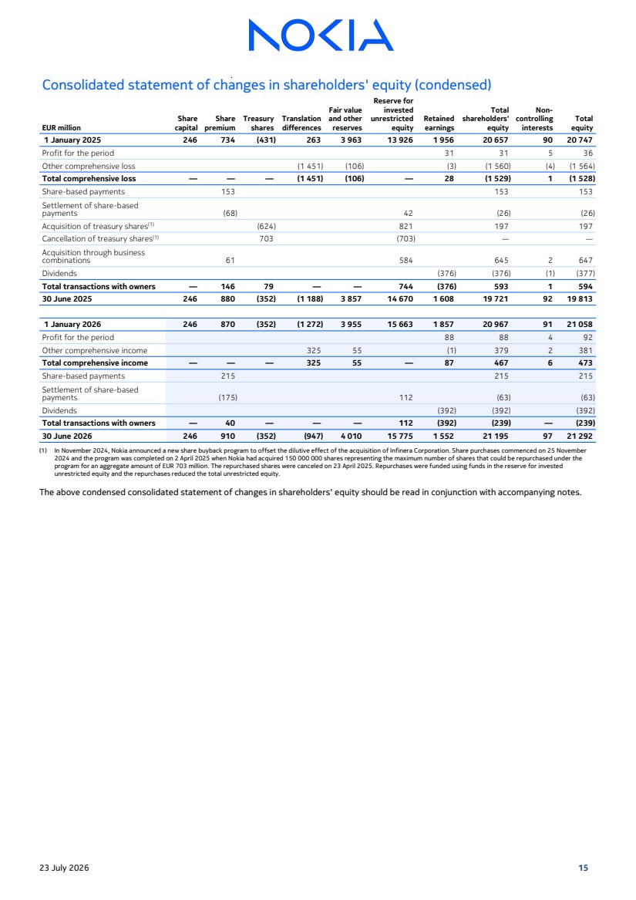 | Consolidated statement of changes in shareholders' equity (condensed) EUR million Share capital Share premium Treasury shares Translation differences Fair value and other reserves Reserve for invested unrestricted equity Retained earnings Total shareholders' equity Non-controlling interests Total equity 1 January 2025 246 734 (431) 263 3 963 13 926 1 956 20 657 90 20 747 Profit for the period 31 31 5 36 Other comprehensive loss (1 451) (106) (3) (1 560) (4) (1 564) Total comprehensive loss — — — (1 451) (106) — 28 (1 529) 1 (1 528) Share-based payments 153 153 153 Settlement of share-based payments (68) 42 (26) (26) Acquisition of treasury shares(1) (624) 821 197 197 Cancellation of treasury shares(1) 703 (703) — — Acquisition through business combinations 61 584 645 2 647 Dividends (376) (376) (1) (377) Total transactions with owners — 146 79 — — 744 (376) 593 1 594 30 June 2025 246 880 (352) (1 188) 3 857 14 670 1 608 19 721 92 19 813 1 January 2026 246 870 (352) (1 272) 3 955 15 663 1 857 20 967 91 21 058 Profit for the period 88 88 4 92 Other comprehensive income 325 55 (1) 379 2 381 Total comprehensive income — — — 325 55 — 87 467 6 473 Share-based payments 215 215 215 Settlement of share-based payments (175) 112 (63) (63) Dividends (392) (392) (392) Total transactions with owners — 40 — — — 112 (392) (239) — (239) 30 June 2026 246 910 (352) (947) 4 010 15 775 1 552 21 195 97 21 292 (1) In November 2024, Nokia announced a new share buyback program to offset the dilutive effect of the acquisition of Infinera Corporation. Share purchases commenced on 25 November 2024 and the program was completed on 2 April 2025 when Nokia had acquired 150 000 000 shares representing the maximum number of shares that could be repurchased under the program for an aggregate amount of EUR 703 million. The repurchased shares were canceled on 23 April 2025. Repurchases were funded using funds in the reserve for invested unrestricted equity and the repurchases reduced the total unrestricted equity. The above condensed consolidated statement of changes in shareholders' equity should be read in conjunction with accompanying notes. 23 July 2026 15
 | 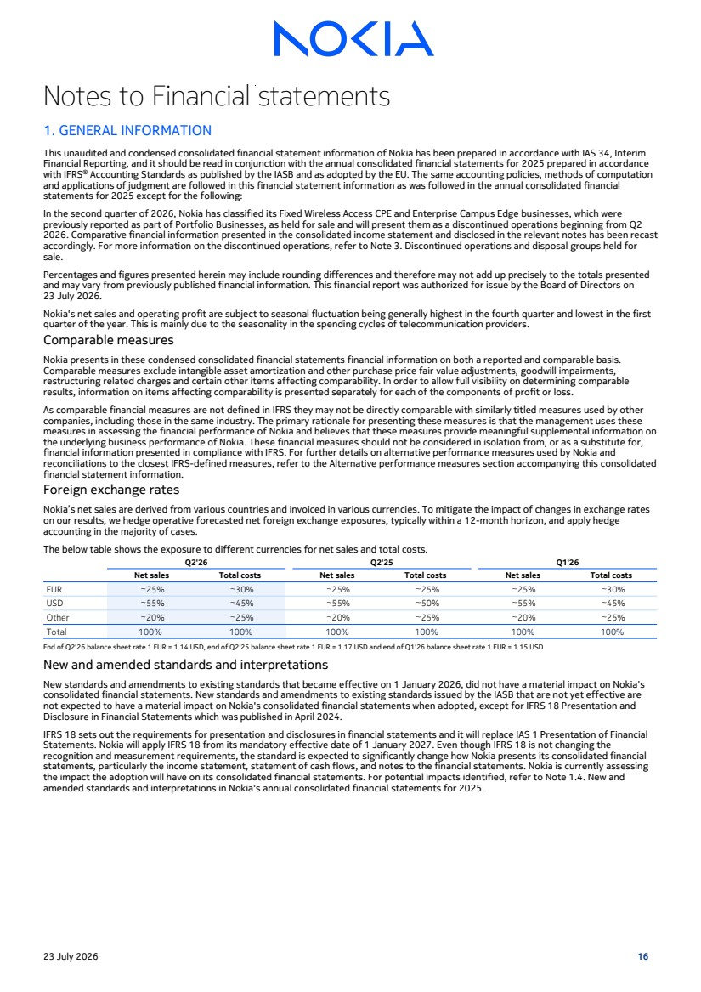 | Notes to Financial statements 1. GENERAL INFORMATION This unaudited and condensed consolidated financial statement information of Nokia has been prepared in accordance with IAS 34, Interim Financial Reporting, and it should be read in conjunction with the annual consolidated financial statements for 2025 prepared in accordance with IFRS® Accounting Standards as published by the IASB and as adopted by the EU. The same accounting policies, methods of computation and applications of judgment are followed in this financial statement information as was followed in the annual consolidated financial statements for 2025 except for the following: In the second quarter of 2026, Nokia has classified its Fixed Wireless Access CPE and Enterprise Campus Edge businesses, which were previously reported as part of Portfolio Businesses, as held for sale and will present them as a discontinued operations beginning from Q2 2026. Comparative financial information presented in the consolidated income statement and disclosed in the relevant notes has been recast accordingly. For more information on the discontinued operations, refer to Note 3. Discontinued operations and disposal groups held for sale. Percentages and figures presented herein may include rounding differences and therefore may not add up precisely to the totals presented and may vary from previously published financial information. This financial report was authorized for issue by the Board of Directors on 23 July 2026. Nokia's net sales and operating profit are subject to seasonal fluctuation being generally highest in the fourth quarter and lowest in the first quarter of the year. This is mainly due to the seasonality in the spending cycles of telecommunication providers. Comparable measures Nokia presents in these condensed consolidated financial statements financial information on both a reported and comparable basis. Comparable measures exclude intangible asset amortization and other purchase price fair value adjustments, goodwill impairments, restructuring related charges and certain other items affecting comparability. In order to allow full visibility on determining comparable results, information on items affecting comparability is presented separately for each of the components of profit or loss. As comparable financial measures are not defined in IFRS they may not be directly comparable with similarly titled measures used by other companies, including those in the same industry. The primary rationale for presenting these measures is that the management uses these measures in assessing the financial performance of Nokia and believes that these measures provide meaningful supplemental information on the underlying business performance of Nokia. These financial measures should not be considered in isolation from, or as a substitute for, financial information presented in compliance with IFRS. For further details on alternative performance measures used by Nokia and reconciliations to the closest IFRS-defined measures, refer to the Alternative performance measures section accompanying this consolidated financial statement information. Foreign exchange rates Nokia’s net sales are derived from various countries and invoiced in various currencies. To mitigate the impact of changes in exchange rates on our results, we hedge operative forecasted net foreign exchange exposures, typically within a 12-month horizon, and apply hedge accounting in the majority of cases. The below table shows the exposure to different currencies for net sales and total costs. Q2'26 Q2'25 Q1'26 Net sales Total costs Net sales Total costs Net sales Total costs EUR ~25% ~30% ~25% ~25% ~25% ~30% USD ~55% ~45% ~55% ~50% ~55% ~45% Other ~20% ~25% ~20% ~25% ~20% ~25% Total 100% 100% 100% 100% 100% 100% End of Q2'26 balance sheet rate 1 EUR = 1.14 USD, end of Q2'25 balance sheet rate 1 EUR = 1.17 USD and end of Q1'26 balance sheet rate 1 EUR = 1.15 USD New and amended standards and interpretations New standards and amendments to existing standards that became effective on 1 January 2026, did not have a material impact on Nokia's consolidated financial statements. New standards and amendments to existing standards issued by the IASB that are not yet effective are not expected to have a material impact on Nokia's consolidated financial statements when adopted, except for IFRS 18 Presentation and Disclosure in Financial Statements which was published in April 2024. IFRS 18 sets out the requirements for presentation and disclosures in financial statements and it will replace IAS 1 Presentation of Financial Statements. Nokia will apply IFRS 18 from its mandatory effective date of 1 January 2027. Even though IFRS 18 is not changing the recognition and measurement requirements, the standard is expected to significantly change how Nokia presents its consolidated financial statements, particularly the income statement, statement of cash flows, and notes to the financial statements. Nokia is currently assessing the impact the adoption will have on its consolidated financial statements. For potential impacts identified, refer to Note 1.4. New and amended standards and interpretations in Nokia's annual consolidated financial statements for 2025. 23 July 2026 16
 | 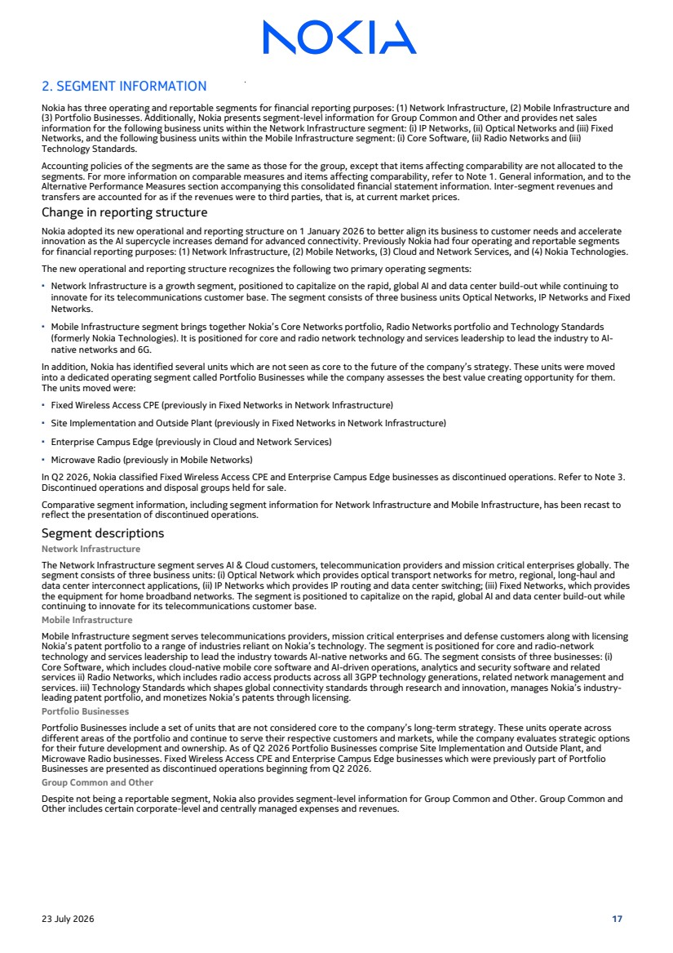 | 2. SEGMENT INFORMATION Nokia has three operating and reportable segments for financial reporting purposes: (1) Network Infrastructure, (2) Mobile Infrastructure and (3) Portfolio Businesses. Additionally, Nokia presents segment-level information for Group Common and Other and provides net sales information for the following business units within the Network Infrastructure segment: (i) IP Networks, (ii) Optical Networks and (iii) Fixed Networks, and the following business units within the Mobile Infrastructure segment: (i) Core Software, (ii) Radio Networks and (iii) Technology Standards. Accounting policies of the segments are the same as those for the group, except that items affecting comparability are not allocated to the segments. For more information on comparable measures and items affecting comparability, refer to Note 1. General information, and to the Alternative Performance Measures section accompanying this consolidated financial statement information. Inter-segment revenues and transfers are accounted for as if the revenues were to third parties, that is, at current market prices. Change in reporting structure Nokia adopted its new operational and reporting structure on 1 January 2026 to better align its business to customer needs and accelerate innovation as the AI supercycle increases demand for advanced connectivity. Previously Nokia had four operating and reportable segments for financial reporting purposes: (1) Network Infrastructure, (2) Mobile Networks, (3) Cloud and Network Services, and (4) Nokia Technologies. The new operational and reporting structure recognizes the following two primary operating segments: ▪ Network Infrastructure is a growth segment, positioned to capitalize on the rapid, global AI and data center build-out while continuing to innovate for its telecommunications customer base. The segment consists of three business units Optical Networks, IP Networks and Fixed Networks. ▪ Mobile Infrastructure segment brings together Nokia’s Core Networks portfolio, Radio Networks portfolio and Technology Standards (formerly Nokia Technologies). It is positioned for core and radio network technology and services leadership to lead the industry to AI-native networks and 6G. In addition, Nokia has identified several units which are not seen as core to the future of the company’s strategy. These units were moved into a dedicated operating segment called Portfolio Businesses while the company assesses the best value creating opportunity for them. The units moved were: ▪ Fixed Wireless Access CPE (previously in Fixed Networks in Network Infrastructure) ▪ Site Implementation and Outside Plant (previously in Fixed Networks in Network Infrastructure) ▪ Enterprise Campus Edge (previously in Cloud and Network Services) ▪ Microwave Radio (previously in Mobile Networks) In Q2 2026, Nokia classified Fixed Wireless Access CPE and Enterprise Campus Edge businesses as discontinued operations. Refer to Note 3. Discontinued operations and disposal groups held for sale. Comparative segment information, including segment information for Network Infrastructure and Mobile Infrastructure, has been recast to reflect the presentation of discontinued operations. Segment descriptions Network Infrastructure The Network Infrastructure segment serves AI & Cloud customers, telecommunication providers and mission critical enterprises globally. The segment consists of three business units: (i) Optical Network which provides optical transport networks for metro, regional, long-haul and data center interconnect applications, (ii) IP Networks which provides IP routing and data center switching; (iii) Fixed Networks, which provides the equipment for home broadband networks. The segment is positioned to capitalize on the rapid, global AI and data center build-out while continuing to innovate for its telecommunications customer base. Mobile Infrastructure Mobile Infrastructure segment serves telecommunications providers, mission critical enterprises and defense customers along with licensing Nokia’s patent portfolio to a range of industries reliant on Nokia’s technology. The segment is positioned for core and radio-network technology and services leadership to lead the industry towards AI-native networks and 6G. The segment consists of three businesses: (i) Core Software, which includes cloud-native mobile core software and AI-driven operations, analytics and security software and related services ii) Radio Networks, which includes radio access products across all 3GPP technology generations, related network management and services. iii) Technology Standards which shapes global connectivity standards through research and innovation, manages Nokia’s industry-leading patent portfolio, and monetizes Nokia’s patents through licensing. Portfolio Businesses Portfolio Businesses include a set of units that are not considered core to the company’s long-term strategy. These units operate across different areas of the portfolio and continue to serve their respective customers and markets, while the company evaluates strategic options for their future development and ownership. As of Q2 2026 Portfolio Businesses comprise Site Implementation and Outside Plant, and Microwave Radio businesses. Fixed Wireless Access CPE and Enterprise Campus Edge businesses which were previously part of Portfolio Businesses are presented as discontinued operations beginning from Q2 2026. Group Common and Other Despite not being a reportable segment, Nokia also provides segment-level information for Group Common and Other. Group Common and Other includes certain corporate-level and centrally managed expenses and revenues. 23 July 2026 17
 | 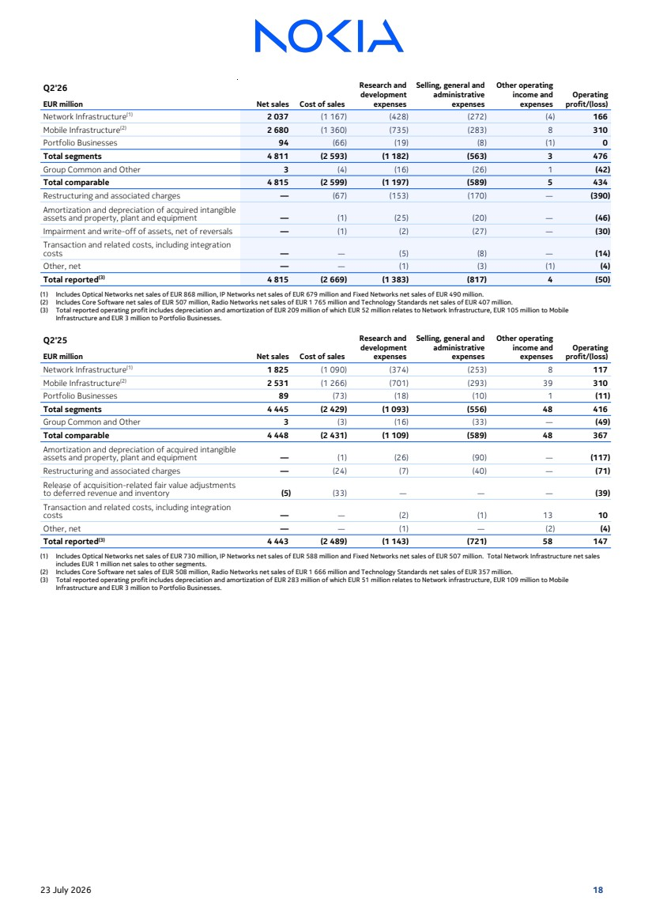 | Q2'26 Net sales Cost of sales Research and development expenses Selling, general and administrative expenses Other operating income and expenses Operating EUR million profit/(loss) Network Infrastructure(1) 2 037 (1 167) (428) (272) (4) 166 Mobile Infrastructure(2) 2 680 (1 360) (735) (283) 8 310 Portfolio Businesses 94 (66) (19) (8) (1) 0 Total segments 4 811 (2 593) (1 182) (563) 3 476 Group Common and Other 3 (4) (16) (26) 1 (42) Total comparable 4 815 (2 599) (1 197) (589) 5 434 Restructuring and associated charges — (67) (153) (170) — (390) Amortization and depreciation of acquired intangible assets and property, plant and equipment — (1) (25) (20) — (46) Impairment and write-off of assets, net of reversals — (1) (2) (27) — (30) Transaction and related costs, including integration costs — — (5) (8) — (14) Other, net — — (1) (3) (1) (4) Total reported(3) 4 815 (2 669) (1 383) (817) 4 (50) (1) Includes Optical Networks net sales of EUR 868 million, IP Networks net sales of EUR 679 million and Fixed Networks net sales of EUR 490 million. (2) Includes Core Software net sales of EUR 507 million, Radio Networks net sales of EUR 1 765 million and Technology Standards net sales of EUR 407 million. (3) Total reported operating profit includes depreciation and amortization of EUR 209 million of which EUR 52 million relates to Network Infrastructure, EUR 105 million to Mobile Infrastructure and EUR 3 million to Portfolio Businesses. Q2'25 Net sales Cost of sales Research and development expenses Selling, general and administrative expenses Other operating income and expenses Operating EUR million profit/(loss) Network Infrastructure(1) 1 825 (1 090) (374) (253) 8 117 Mobile Infrastructure(2) 2 531 (1 266) (701) (293) 39 310 Portfolio Businesses 89 (73) (18) (10) 1 (11) Total segments 4 445 (2 429) (1 093) (556) 48 416 Group Common and Other 3 (3) (16) (33) — (49) Total comparable 4 448 (2 431) (1 109) (589) 48 367 Amortization and depreciation of acquired intangible assets and property, plant and equipment — (1) (26) (90) — (117) Restructuring and associated charges — (24) (7) (40) — (71) Release of acquisition-related fair value adjustments to deferred revenue and inventory (5) (33) — — — (39) Transaction and related costs, including integration costs — — (2) (1) 13 10 Other, net — — (1) — (2) (4) Total reported(3) 4 443 (2 489) (1 143) (721) 58 147 (1) Includes Optical Networks net sales of EUR 730 million, IP Networks net sales of EUR 588 million and Fixed Networks net sales of EUR 507 million. Total Network Infrastructure net sales includes EUR 1 million net sales to other segments. (2) Includes Core Software net sales of EUR 508 million, Radio Networks net sales of EUR 1 666 million and Technology Standards net sales of EUR 357 million. (3) Total reported operating profit includes depreciation and amortization of EUR 283 million of which EUR 51 million relates to Network infrastructure, EUR 109 million to Mobile Infrastructure and EUR 3 million to Portfolio Businesses. 23 July 2026 18
 | 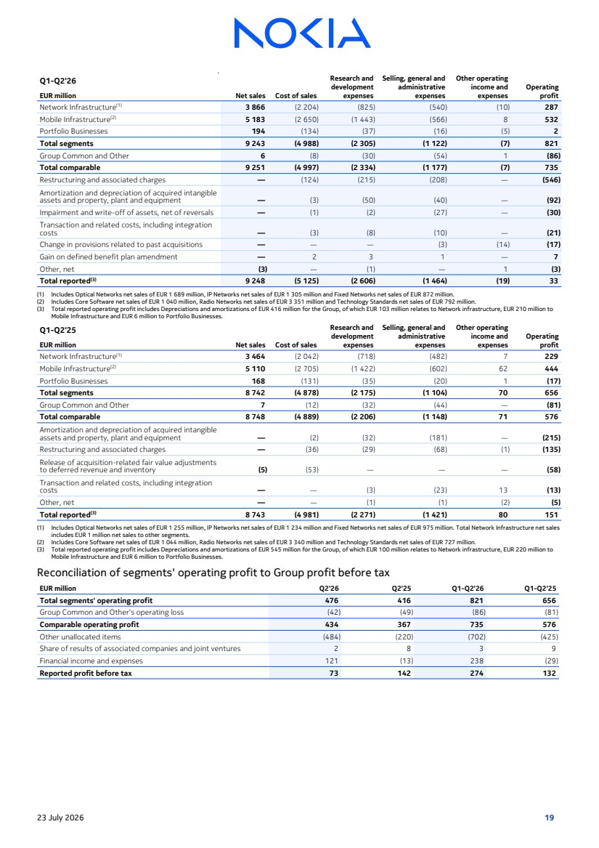 | Q1-Q2'26 Net sales Cost of sales Research and development expenses Selling, general and administrative expenses Other operating income and expenses Operating EUR million profit Network Infrastructure(1) 3 866 (2 204) (825) (540) (10) 287 Mobile Infrastructure(2) 5 183 (2 650) (1 443) (566) 8 532 Portfolio Businesses 194 (134) (37) (16) (5) 2 Total segments 9 243 (4 988) (2 305) (1 122) (7) 821 Group Common and Other 6 (8) (30) (54) 1 (86) Total comparable 9 251 (4 997) (2 334) (1 177) (7) 735 Restructuring and associated charges — (124) (215) (208) — (546) Amortization and depreciation of acquired intangible assets and property, plant and equipment — (3) (50) (40) — (92) Impairment and write-off of assets, net of reversals — (1) (2) (27) — (30) Transaction and related costs, including integration costs — (3) (8) (10) — (21) Change in provisions related to past acquisitions — — — (3) (14) (17) Gain on defined benefit plan amendment — 2 3 1 — 7 Other, net (3) — (1) — 1 (3) Total reported(3) 9 248 (5 125) (2 606) (1 464) (19) 33 (1) Includes Optical Networks net sales of EUR 1 689 million, IP Networks net sales of EUR 1 305 million and Fixed Networks net sales of EUR 872 million. (2) Includes Core Software net sales of EUR 1 040 million, Radio Networks net sales of EUR 3 351 million and Technology Standards net sales of EUR 792 million. (3) Total reported operating profit includes Depreciations and amortizations of EUR 416 million for the Group, of which EUR 103 million relates to Network infrastructure, EUR 210 million to Mobile Infrastructure and EUR 6 million to Portfolio Businesses. Q1-Q2'25 Net sales Cost of sales Research and development expenses Selling, general and administrative expenses Other operating income and expenses Operating EUR million profit Network Infrastructure(1) 3 464 (2 042) (718) (482) 7 229 Mobile Infrastructure(2) 5 110 (2 705) (1 422) (602) 62 444 Portfolio Businesses 168 (131) (35) (20) 1 (17) Total segments 8 742 (4 878) (2 175) (1 104) 70 656 Group Common and Other 7 (12) (32) (44) — (81) Total comparable 8 748 (4 889) (2 206) (1 148) 71 576 Amortization and depreciation of acquired intangible assets and property, plant and equipment — (2) (32) (181) — (215) Restructuring and associated charges — (36) (29) (68) (1) (135) Release of acquisition-related fair value adjustments to deferred revenue and inventory (5) (53) — — — (58) Transaction and related costs, including integration costs — — (3) (23) 13 (13) Other, net — — (1) (1) (2) (5) Total reported(3) 8 743 (4 981) (2 271) (1 421) 80 151 (1) Includes Optical Networks net sales of EUR 1 255 million, IP Networks net sales of EUR 1 234 million and Fixed Networks net sales of EUR 975 million. Total Network Infrastructure net sales includes EUR 1 million net sales to other segments. (2) Includes Core Software net sales of EUR 1 044 million, Radio Networks net sales of EUR 3 340 million and Technology Standards net sales of EUR 727 million. (3) Total reported operating profit includes Depreciations and amortizations of EUR 545 million for the Group, of which EUR 100 million relates to Network infrastructure, EUR 220 million to Mobile Infrastructure and EUR 6 million to Portfolio Businesses. Reconciliation of segments' operating profit to Group profit before tax EUR million Q2'26 Q2'25 Q1-Q2'26 Q1-Q2'25 Total segments' operating profit 476 416 821 656 Group Common and Other's operating loss (42) (49) (86) (81) Comparable operating profit 434 367 735 576 Other unallocated items (484) (220) (702) (425) Share of results of associated companies and joint ventures 2 8 3 9 Financial income and expenses 121 (13) 238 (29) Reported profit before tax 73 142 274 132 23 July 2026 19
 | 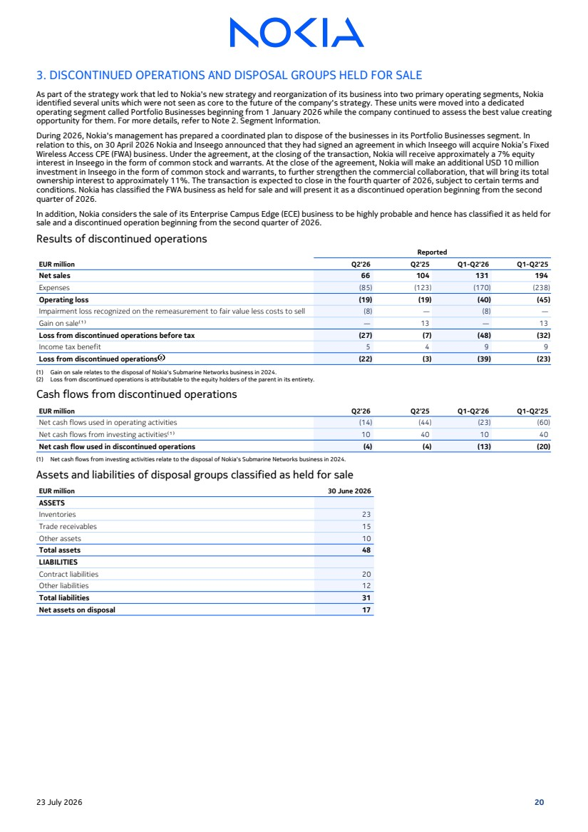 | 3. DISCONTINUED OPERATIONS AND DISPOSAL GROUPS HELD FOR SALE As part of the strategy work that led to Nokia's new strategy and reorganization of its business into two primary operating segments, Nokia identified several units which were not seen as core to the future of the company's strategy. These units were moved into a dedicated operating segment called Portfolio Businesses beginning from 1 January 2026 while the company continued to assess the best value creating opportunity for them. For more details, refer to Note 2. Segment Information. During 2026, Nokia's management has prepared a coordinated plan to dispose of the businesses in its Portfolio Businesses segment. In relation to this, on 30 April 2026 Nokia and Inseego announced that they had signed an agreement in which Inseego will acquire Nokia’s Fixed Wireless Access CPE (FWA) business. Under the agreement, at the closing of the transaction, Nokia will receive approximately a 7% equity interest in Inseego in the form of common stock and warrants. At the close of the agreement, Nokia will make an additional USD 10 million investment in Inseego in the form of common stock and warrants, to further strengthen the commercial collaboration, that will bring its total ownership interest to approximately 11%. The transaction is expected to close in the fourth quarter of 2026, subject to certain terms and conditions. Nokia has classified the FWA business as held for sale and will present it as a discontinued operation beginning from the second quarter of 2026. In addition, Nokia considers the sale of its Enterprise Campus Edge (ECE) business to be highly probable and hence has classified it as held for sale and a discontinued operation beginning from the second quarter of 2026. Results of discontinued operations Reported EUR million Q2'26 Q2'25 Q1-Q2'26 Q1-Q2'25 Net sales 66 104 131 194 Expenses (85) (123) (170) (238) Operating loss (19) (19) (40) (45) Impairment loss recognized on the remeasurement to fair value less costs to sell (8) — (8) — Gain on sale⁽¹⁾ — 13 — 13 Loss from discontinued operations before tax (27) (7) (48) (32) Income tax benefit 5 4 9 9 Loss from discontinued operations⁽²⁾ (22) (3) (39) (23) (1) Gain on sale relates to the disposal of Nokia's Submarine Networks business in 2024. (2) Loss from discontinued operations is attributable to the equity holders of the parent in its entirety. Cash flows from discontinued operations EUR million Q2'26 Q2'25 Q1-Q2'26 Q1-Q2'25 Net cash flows used in operating activities (14) (44) (23) (60) Net cash flows from investing activities⁽¹⁾ 10 40 10 40 Net cash flow used in discontinued operations (4) (4) (13) (20) (1) Net cash flows from investing activities relate to the disposal of Nokia's Submarine Networks business in 2024. Assets and liabilities of disposal groups classified as held for sale EUR million 30 June 2026 ASSETS Inventories 23 Trade receivables 15 Other assets 10 Total assets 48 LIABILITIES Contract liabilities 20 Other liabilities 12 Total liabilities 31 Net assets on disposal 17 23 July 2026 20
 | 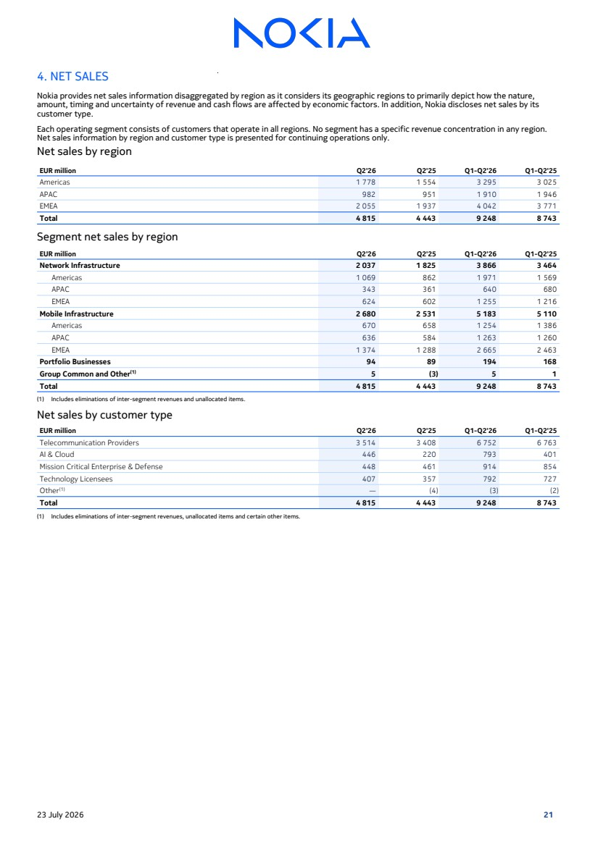 | 4. NET SALES Nokia provides net sales information disaggregated by region as it considers its geographic regions to primarily depict how the nature, amount, timing and uncertainty of revenue and cash flows are affected by economic factors. In addition, Nokia discloses net sales by its customer type. Each operating segment consists of customers that operate in all regions. No segment has a specific revenue concentration in any region. Net sales information by region and customer type is presented for continuing operations only. Net sales by region EUR million Q2'26 Q2'25 Q1-Q2'26 Q1-Q2'25 Americas 1 778 1 554 3 295 3 025 APAC 982 951 1 910 1 946 EMEA 2 055 1 937 4 042 3 771 Total 4 815 4 443 9 248 8 743 Segment net sales by region EUR million Q2'26 Q2'25 Q1-Q2'26 Q1-Q2'25 Network Infrastructure 2 037 1 825 3 866 3 464 Americas 1 069 862 1 971 1 569 APAC 343 361 640 680 EMEA 624 602 1 255 1 216 Mobile Infrastructure 2 680 2 531 5 183 5 110 Americas 670 658 1 254 1 386 APAC 636 584 1 263 1 260 EMEA 1 374 1 288 2 665 2 463 Portfolio Businesses 94 89 194 168 Group Common and Other(1) 5 (3) 5 1 Total 4 815 4 443 9 248 8 743 (1) Includes eliminations of inter-segment revenues and unallocated items. Net sales by customer type EUR million Q2'26 Q2'25 Q1-Q2'26 Q1-Q2'25 Telecommunication Providers 3 514 3 408 6 752 6 763 AI & Cloud 446 220 793 401 Mission Critical Enterprise & Defense 448 461 914 854 Technology Licensees 407 357 792 727 Other(1) — (4) (3) (2) Total 4 815 4 443 9 248 8 743 (1) Includes eliminations of inter-segment revenues, unallocated items and certain other items. 23 July 2026 21
 | 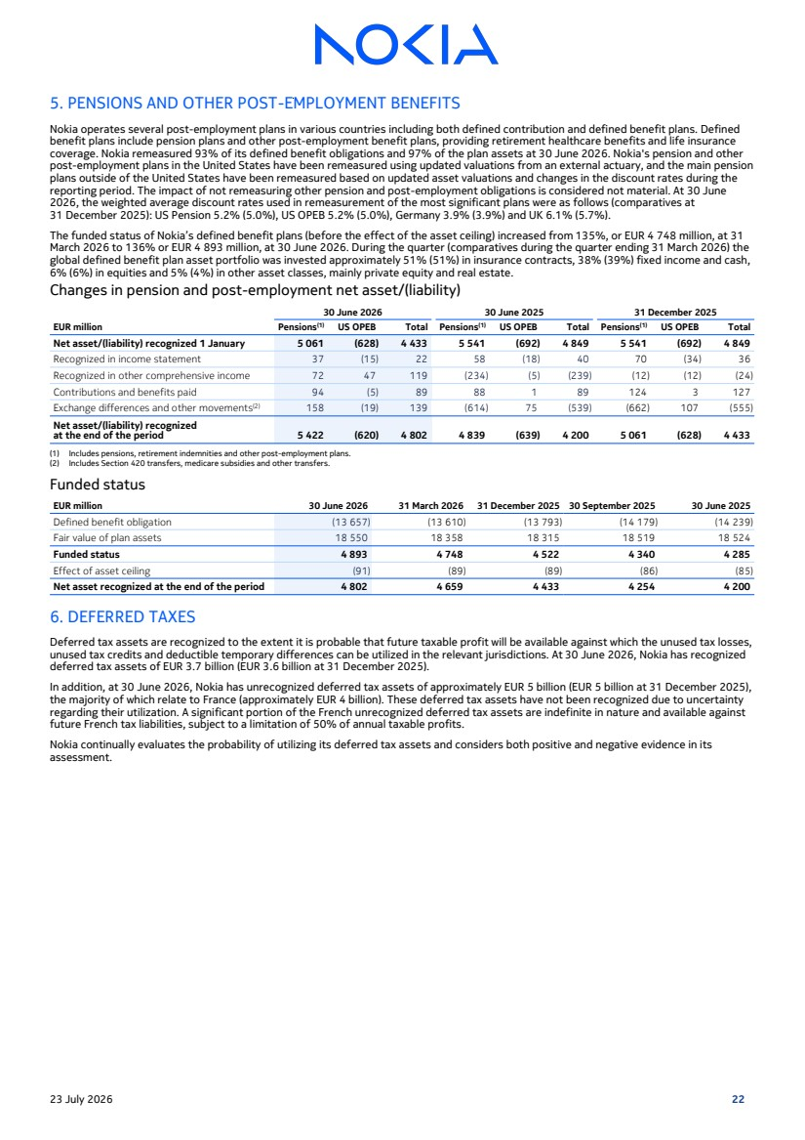 | 5. PENSIONS AND OTHER POST-EMPLOYMENT BENEFITS Nokia operates several post-employment plans in various countries including both defined contribution and defined benefit plans. Defined benefit plans include pension plans and other post-employment benefit plans, providing retirement healthcare benefits and life insurance coverage. Nokia remeasured 93% of its defined benefit obligations and 97% of the plan assets at 30 June 2026. Nokia's pension and other post-employment plans in the United States have been remeasured using updated valuations from an external actuary, and the main pension plans outside of the United States have been remeasured based on updated asset valuations and changes in the discount rates during the reporting period. The impact of not remeasuring other pension and post-employment obligations is considered not material. At 30 June 2026, the weighted average discount rates used in remeasurement of the most significant plans were as follows (comparatives at 31 December 2025): US Pension 5.2% (5.0%), US OPEB 5.2% (5.0%), Germany 3.9% (3.9%) and UK 6.1% (5.7%). The funded status of Nokia’s defined benefit plans (before the effect of the asset ceiling) increased from 135%, or EUR 4 748 million, at 31 March 2026 to 136% or EUR 4 893 million, at 30 June 2026. During the quarter (comparatives during the quarter ending 31 March 2026) the global defined benefit plan asset portfolio was invested approximately 51% (51%) in insurance contracts, 38% (39%) fixed income and cash, 6% (6%) in equities and 5% (4%) in other asset classes, mainly private equity and real estate. Changes in pension and post-employment net asset/(liability) 30 June 2026 30 June 2025 31 December 2025 EUR million Pensions(1) US OPEB Total Pensions(1) US OPEB Total Pensions(1) US OPEB Total Net asset/(liability) recognized 1 January 5 061 (628) 4 433 5 541 (692) 4 849 5 541 (692) 4 849 Recognized in income statement 37 (15) 22 58 (18) 40 70 (34) 36 Recognized in other comprehensive income 72 47 119 (234) (5) (239) (12) (12) (24) Contributions and benefits paid 94 (5) 89 88 1 89 124 3 127 Exchange differences and other movements(2) 158 (19) 139 (614) 75 (539) (662) 107 (555) Net asset/(liability) recognized at the end of the period 5 422 (620) 4 802 4 839 (639) 4 200 5 061 (628) 4 433 (1) Includes pensions, retirement indemnities and other post-employment plans. (2) Includes Section 420 transfers, medicare subsidies and other transfers. Funded status EUR million 30 June 2026 31 March 2026 31 December 2025 30 September 2025 30 June 2025 Defined benefit obligation (13 657) (13 610) (13 793) (14 179) (14 239) Fair value of plan assets 18 550 18 358 18 315 18 519 18 524 Funded status 4 893 4 748 4 522 4 340 4 285 Effect of asset ceiling (91) (89) (89) (86) (85) Net asset recognized at the end of the period 4 802 4 659 4 433 4 254 4 200 6. DEFERRED TAXES Deferred tax assets are recognized to the extent it is probable that future taxable profit will be available against which the unused tax losses, unused tax credits and deductible temporary differences can be utilized in the relevant jurisdictions. At 30 June 2026, Nokia has recognized deferred tax assets of EUR 3.7 billion (EUR 3.6 billion at 31 December 2025). In addition, at 30 June 2026, Nokia has unrecognized deferred tax assets of approximately EUR 5 billion (EUR 5 billion at 31 December 2025), the majority of which relate to France (approximately EUR 4 billion). These deferred tax assets have not been recognized due to uncertainty regarding their utilization. A significant portion of the French unrecognized deferred tax assets are indefinite in nature and available against future French tax liabilities, subject to a limitation of 50% of annual taxable profits. Nokia continually evaluates the probability of utilizing its deferred tax assets and considers both positive and negative evidence in its assessment. 23 July 2026 22
 | 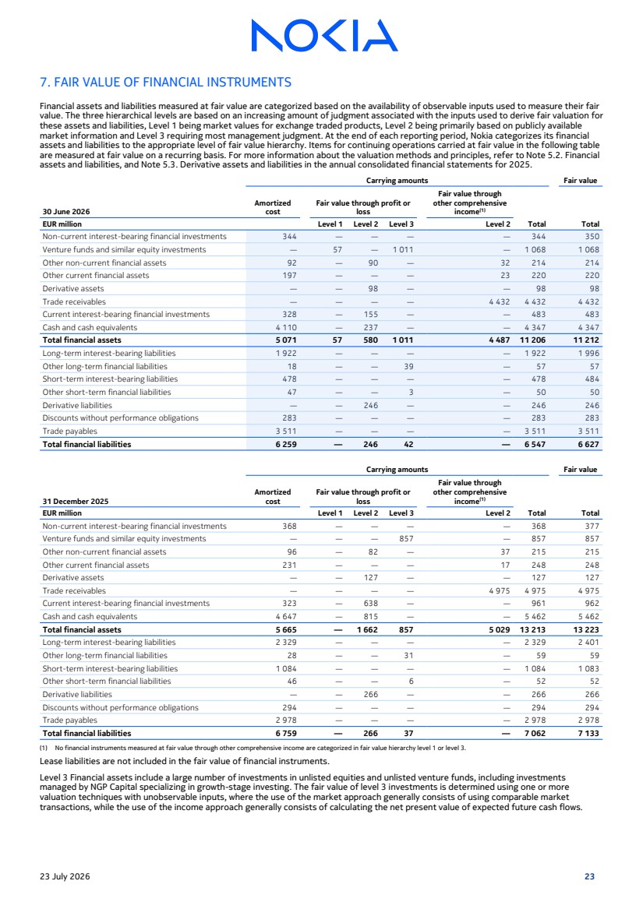 | 7. FAIR VALUE OF FINANCIAL INSTRUMENTS Financial assets and liabilities measured at fair value are categorized based on the availability of observable inputs used to measure their fair value. The three hierarchical levels are based on an increasing amount of judgment associated with the inputs used to derive fair valuation for these assets and liabilities, Level 1 being market values for exchange traded products, Level 2 being primarily based on publicly available market information and Level 3 requiring most management judgment. At the end of each reporting period, Nokia categorizes its financial assets and liabilities to the appropriate level of fair value hierarchy. Items for continuing operations carried at fair value in the following table are measured at fair value on a recurring basis. For more information about the valuation methods and principles, refer to Note 5.2. Financial assets and liabilities, and Note 5.3. Derivative assets and liabilities in the annual consolidated financial statements for 2025. 30 June 2026 Carrying amounts Fair value Amortized cost Fair value through profit or loss Fair value through other comprehensive income(1) EUR million Level 1 Level 2 Level 3 Level 2 Total Total Non-current interest-bearing financial investments 344 — — — — 344 350 Venture funds and similar equity investments — 57 — 1 011 — 1 068 1 068 Other non-current financial assets 92 — 90 — 32 214 214 Other current financial assets 197 — — — 23 220 220 Derivative assets — — 98 — — 98 98 Trade receivables — — — — 4 432 4 432 4 432 Current interest-bearing financial investments 328 — 155 — — 483 483 Cash and cash equivalents 4 110 — 237 — — 4 347 4 347 Total financial assets 5 071 57 580 1 011 4 487 11 206 11 212 Long-term interest-bearing liabilities 1 922 — — — — 1 922 1 996 Other long-term financial liabilities 18 — — 39 — 57 57 Short-term interest-bearing liabilities 478 — — — — 478 484 Other short-term financial liabilities 47 — — 3 — 50 50 Derivative liabilities — — 246 — — 246 246 Discounts without performance obligations 283 — — — — 283 283 Trade payables 3 511 — — — — 3 511 3 511 Total financial liabilities 6 259 — 246 42 — 6 547 6 627 31 December 2025 Carrying amounts Fair value Amortized cost Fair value through profit or loss Fair value through other comprehensive income(1) EUR million Level 1 Level 2 Level 3 Level 2 Total Total Non-current interest-bearing financial investments 368 — — — — 368 377 Venture funds and similar equity investments — — — 857 — 857 857 Other non-current financial assets 96 — 82 — 37 215 215 Other current financial assets 231 — — — 17 248 248 Derivative assets — — 127 — — 127 127 Trade receivables — — — — 4 975 4 975 4 975 Current interest-bearing financial investments 323 — 638 — — 961 962 Cash and cash equivalents 4 647 — 815 — — 5 462 5 462 Total financial assets 5 665 — 1 662 857 5 029 13 213 13 223 Long-term interest-bearing liabilities 2 329 — — — — 2 329 2 401 Other long-term financial liabilities 28 — — 31 — 59 59 Short-term interest-bearing liabilities 1 084 — — — — 1 084 1 083 Other short-term financial liabilities 46 — — 6 — 52 52 Derivative liabilities — — 266 — — 266 266 Discounts without performance obligations 294 — — — — 294 294 Trade payables 2 978 — — — — 2 978 2 978 Total financial liabilities 6 759 — 266 37 — 7 062 7 133 (1) No financial instruments measured at fair value through other comprehensive income are categorized in fair value hierarchy level 1 or level 3. Lease liabilities are not included in the fair value of financial instruments. Level 3 Financial assets include a large number of investments in unlisted equities and unlisted venture funds, including investments managed by NGP Capital specializing in growth-stage investing. The fair value of level 3 investments is determined using one or more valuation techniques with unobservable inputs, where the use of the market approach generally consists of using comparable market transactions, while the use of the income approach generally consists of calculating the net present value of expected future cash flows. 23 July 2026 23
 | 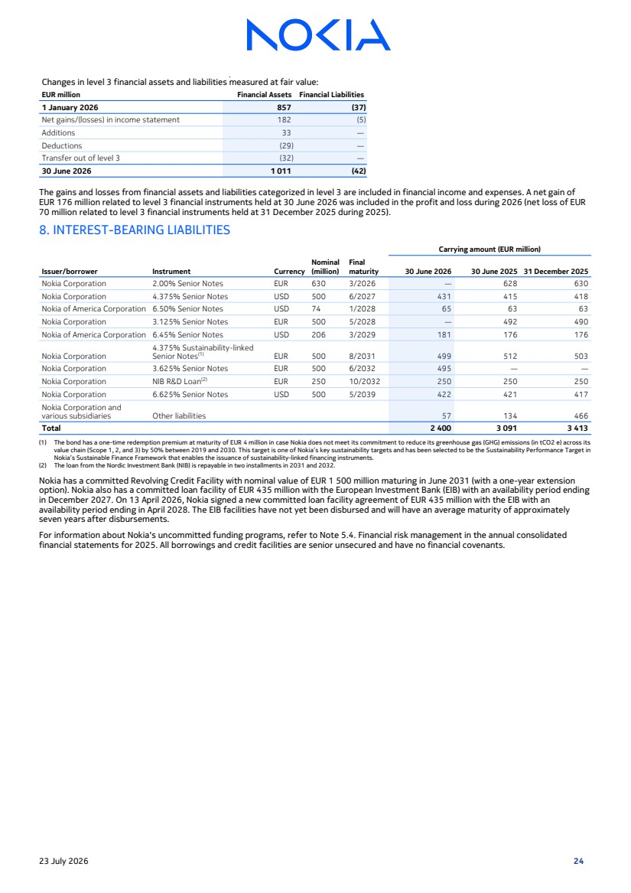 | Changes in level 3 financial assets and liabilities measured at fair value: EUR million Financial Assets Financial Liabilities 1 January 2026 857 (37) Net gains/(losses) in income statement 182 (5) Additions 33 — Deductions (29) — Transfer out of level 3 (32) — 30 June 2026 1 011 (42) The gains and losses from financial assets and liabilities categorized in level 3 are included in financial income and expenses. A net gain of EUR 176 million related to level 3 financial instruments held at 30 June 2026 was included in the profit and loss during 2026 (net loss of EUR 70 million related to level 3 financial instruments held at 31 December 2025 during 2025). 8. INTEREST-BEARING LIABILITIES Carrying amount (EUR million) Issuer/borrower Instrument Currency Nominal (million) Final maturity 30 June 2026 30 June 2025 31 December 2025 Nokia Corporation 2.00% Senior Notes EUR 630 3/2026 — 628 630 Nokia Corporation 4.375% Senior Notes USD 500 6/2027 431 415 418 Nokia of America Corporation 6.50% Senior Notes USD 74 1/2028 65 63 63 Nokia Corporation 3.125% Senior Notes EUR 500 5/2028 — 492 490 Nokia of America Corporation 6.45% Senior Notes USD 206 3/2029 181 176 176 Nokia Corporation 4.375% Sustainability-linked Senior Notes(1) EUR 500 8/2031 499 512 503 Nokia Corporation 3.625% Senior Notes EUR 500 6/2032 495 — — Nokia Corporation NIB R&D Loan(2) EUR 250 10/2032 250 250 250 Nokia Corporation 6.625% Senior Notes USD 500 5/2039 422 421 417 Nokia Corporation and various subsidiaries Other liabilities 57 134 466 Total 2 400 3 091 3 413 (1) The bond has a one-time redemption premium at maturity of EUR 4 million in case Nokia does not meet its commitment to reduce its greenhouse gas (GHG) emissions (in tCO2 e) across its value chain (Scope 1, 2, and 3) by 50% between 2019 and 2030. This target is one of Nokia’s key sustainability targets and has been selected to be the Sustainability Performance Target in Nokia’s Sustainable Finance Framework that enables the issuance of sustainability-linked financing instruments. (2) The loan from the Nordic Investment Bank (NIB) is repayable in two installments in 2031 and 2032. Nokia has a committed Revolving Credit Facility with nominal value of EUR 1 500 million maturing in June 2031 (with a one-year extension option). Nokia also has a committed loan facility of EUR 435 million with the European Investment Bank (EIB) with an availability period ending in December 2027. On 13 April 2026, Nokia signed a new committed loan facility agreement of EUR 435 million with the EIB with an availability period ending in April 2028. The EIB facilities have not yet been disbursed and will have an average maturity of approximately seven years after disbursements. For information about Nokia's uncommitted funding programs, refer to Note 5.4. Financial risk management in the annual consolidated financial statements for 2025. All borrowings and credit facilities are senior unsecured and have no financial covenants. 23 July 2026 24
 | 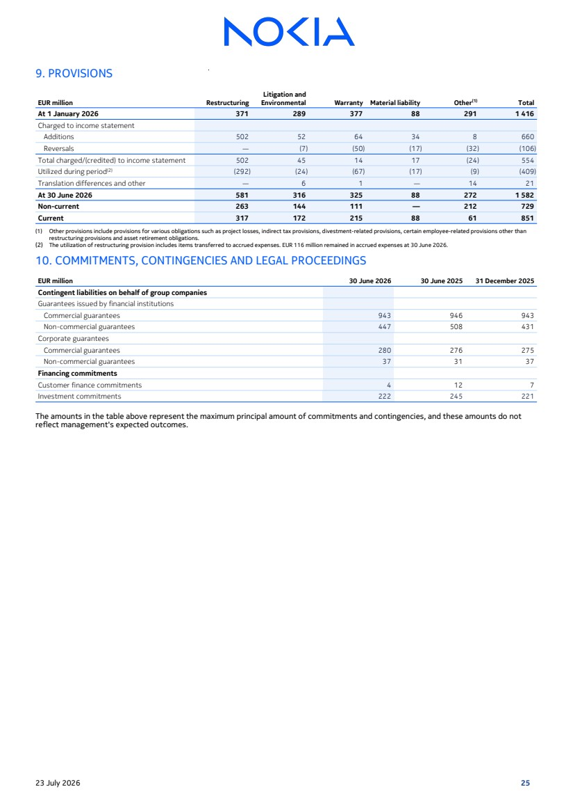 | 9. PROVISIONS EUR million Restructuring Litigation and Environmental Warranty Material liability Other(1) Total At 1 January 2026 371 289 377 88 291 1 416 Charged to income statement Additions 502 52 64 34 8 660 Reversals — (7) (50) (17) (32) (106) Total charged/(credited) to income statement 502 45 14 17 (24) 554 Utilized during period(2) (292) (24) (67) (17) (9) (409) Translation differences and other — 6 1 — 14 21 At 30 June 2026 581 316 325 88 272 1 582 Non-current 263 144 111 — 212 729 Current 317 172 215 88 61 851 (1) Other provisions include provisions for various obligations such as project losses, indirect tax provisions, divestment-related provisions, certain employee-related provisions other than restructuring provisions and asset retirement obligations. (2) The utilization of restructuring provision includes items transferred to accrued expenses. EUR 116 million remained in accrued expenses at 30 June 2026. 10. COMMITMENTS, CONTINGENCIES AND LEGAL PROCEEDINGS EUR million 30 June 2026 30 June 2025 31 December 2025 Contingent liabilities on behalf of group companies Guarantees issued by financial institutions Commercial guarantees 943 946 943 Non-commercial guarantees 447 508 431 Corporate guarantees Commercial guarantees 280 276 275 Non-commercial guarantees 37 31 37 Financing commitments Customer finance commitments 4 12 7 Investment commitments 222 245 221 The amounts in the table above represent the maximum principal amount of commitments and contingencies, and these amounts do not reflect management's expected outcomes. 23 July 2026 25
 | 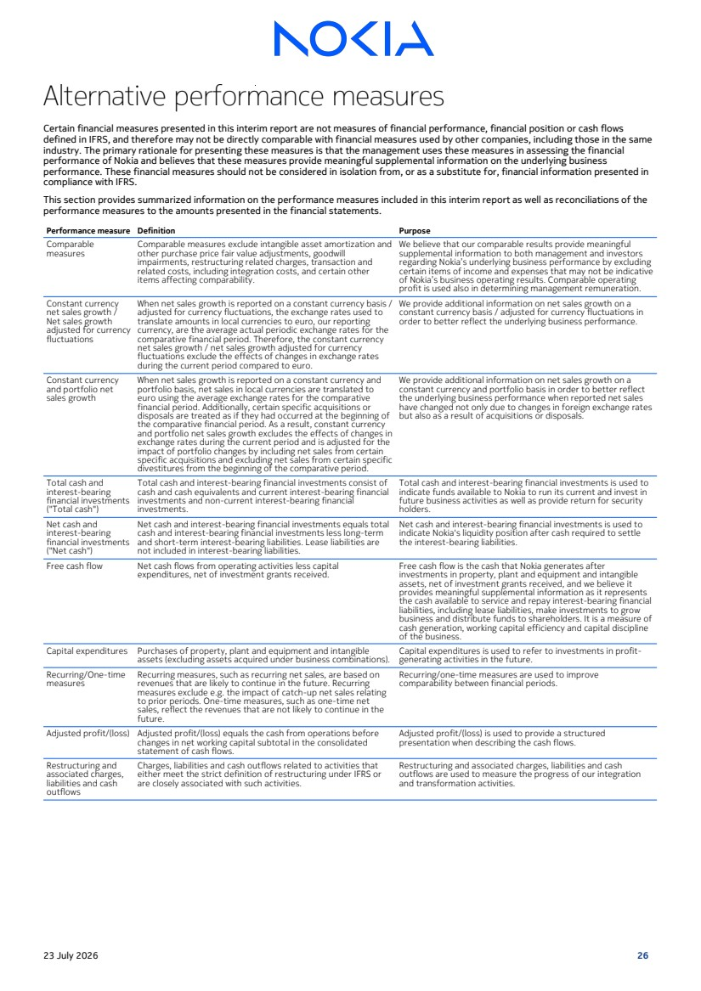 | Alternative performance measures Certain financial measures presented in this interim report are not measures of financial performance, financial position or cash flows defined in IFRS, and therefore may not be directly comparable with financial measures used by other companies, including those in the same industry. The primary rationale for presenting these measures is that the management uses these measures in assessing the financial performance of Nokia and believes that these measures provide meaningful supplemental information on the underlying business performance. These financial measures should not be considered in isolation from, or as a substitute for, financial information presented in compliance with IFRS. This section provides summarized information on the performance measures included in this interim report as well as reconciliations of the performance measures to the amounts presented in the financial statements. Performance measure Definition Purpose Comparable measures Comparable measures exclude intangible asset amortization and other purchase price fair value adjustments, goodwill impairments, restructuring related charges, transaction and related costs, including integration costs, and certain other items affecting comparability. We believe that our comparable results provide meaningful supplemental information to both management and investors regarding Nokia’s underlying business performance by excluding certain items of income and expenses that may not be indicative of Nokia’s business operating results. Comparable operating profit is used also in determining management remuneration. Constant currency net sales growth / Net sales growth adjusted for currency fluctuations When net sales growth is reported on a constant currency basis / adjusted for currency fluctuations, the exchange rates used to translate amounts in local currencies to euro, our reporting currency, are the average actual periodic exchange rates for the comparative financial period. Therefore, the constant currency net sales growth / net sales growth adjusted for currency fluctuations exclude the effects of changes in exchange rates during the current period compared to euro. We provide additional information on net sales growth on a constant currency basis / adjusted for currency fluctuations in order to better reflect the underlying business performance. Constant currency and portfolio net sales growth When net sales growth is reported on a constant currency and portfolio basis, net sales in local currencies are translated to euro using the average exchange rates for the comparative financial period. Additionally, certain specific acquisitions or disposals are treated as if they had occurred at the beginning of the comparative financial period. As a result, constant currency and portfolio net sales growth excludes the effects of changes in exchange rates during the current period and is adjusted for the impact of portfolio changes by including net sales from certain specific acquisitions and excluding net sales from certain specific divestitures from the beginning of the comparative period. We provide additional information on net sales growth on a constant currency and portfolio basis in order to better reflect the underlying business performance when reported net sales have changed not only due to changes in foreign exchange rates but also as a result of acquisitions or disposals. Total cash and interest-bearing financial investments ("Total cash") Total cash and interest-bearing financial investments consist of cash and cash equivalents and current interest-bearing financial investments and non-current interest-bearing financial investments. Total cash and interest-bearing financial investments is used to indicate funds available to Nokia to run its current and invest in future business activities as well as provide return for security holders. Net cash and interest-bearing financial investments ("Net cash") Net cash and interest-bearing financial investments equals total cash and interest-bearing financial investments less long-term and short-term interest-bearing liabilities. Lease liabilities are not included in interest-bearing liabilities. Net cash and interest-bearing financial investments is used to indicate Nokia's liquidity position after cash required to settle the interest-bearing liabilities. Free cash flow Net cash flows from operating activities less capital expenditures, net of investment grants received. Free cash flow is the cash that Nokia generates after investments in property, plant and equipment and intangible assets, net of investment grants received, and we believe it provides meaningful supplemental information as it represents the cash available to service and repay interest-bearing financial liabilities, including lease liabilities, make investments to grow business and distribute funds to shareholders. It is a measure of cash generation, working capital efficiency and capital discipline of the business. Capital expenditures Purchases of property, plant and equipment and intangible assets (excluding assets acquired under business combinations). Capital expenditures is used to refer to investments in profit-generating activities in the future. Recurring/One-time measures Recurring measures, such as recurring net sales, are based on revenues that are likely to continue in the future. Recurring measures exclude e.g. the impact of catch-up net sales relating to prior periods. One-time measures, such as one-time net sales, reflect the revenues that are not likely to continue in the future. Recurring/one-time measures are used to improve comparability between financial periods. Adjusted profit/(loss) Adjusted profit/(loss) equals the cash from operations before changes in net working capital subtotal in the consolidated statement of cash flows. Adjusted profit/(loss) is used to provide a structured presentation when describing the cash flows. Restructuring and associated charges, liabilities and cash outflows Charges, liabilities and cash outflows related to activities that either meet the strict definition of restructuring under IFRS or are closely associated with such activities. Restructuring and associated charges, liabilities and cash outflows are used to measure the progress of our integration and transformation activities. 23 July 2026 26
 | 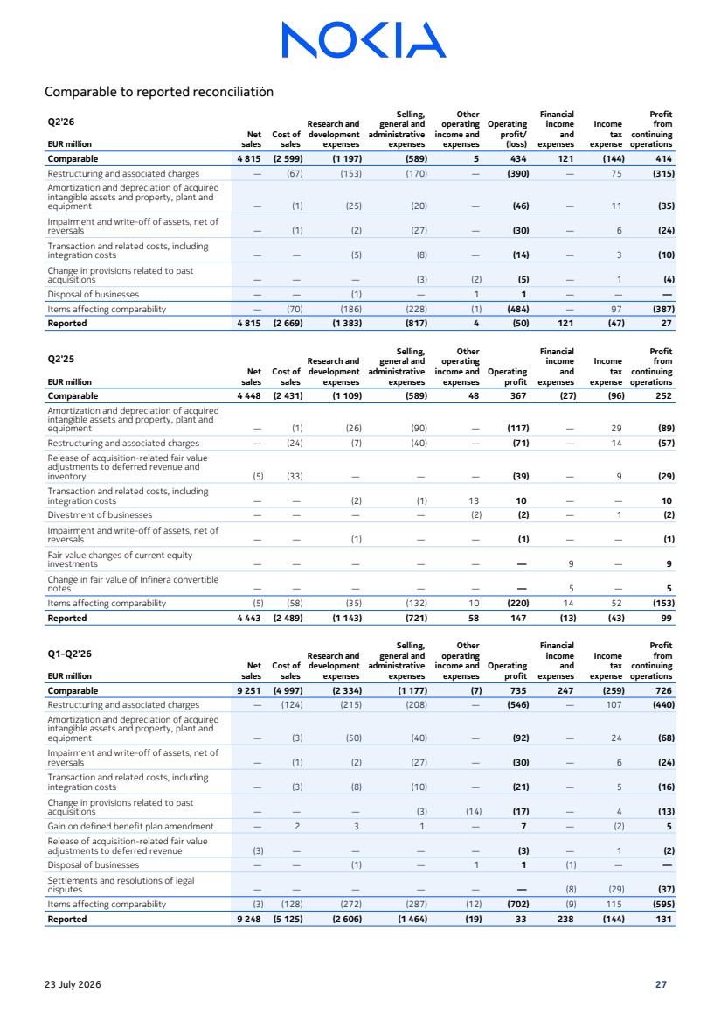 | Comparable to reported reconciliation Q2'26 Net sales Cost of sales Research and development expenses Selling, general and administrative expenses Other operating income and expenses Operating profit/ (loss) Financial income and expenses Income tax expense Profit from continuing EUR million operations Comparable 4 815 (2 599) (1 197) (589) 5 434 121 (144) 414 Restructuring and associated charges — (67) (153) (170) — (390) — 75 (315) Amortization and depreciation of acquired intangible assets and property, plant and equipment — (1) (25) (20) — (46) — 11 (35) Impairment and write-off of assets, net of reversals — (1) (2) (27) — (30) — 6 (24) Transaction and related costs, including integration costs — — (5) (8) — (14) — 3 (10) Change in provisions related to past acquisitions — — — (3) (2) (5) — 1 (4) Disposal of businesses — — (1) — 1 1 — — — Items affecting comparability — (70) (186) (228) (1) (484) — 97 (387) Reported 4 815 (2 669) (1 383) (817) 4 (50) 121 (47) 27 Q2'25 Net sales Cost of sales Research and development expenses Selling, general and administrative expenses Other operating income and expenses Operating profit Financial income and expenses Income tax expense Profit from continuing EUR million operations Comparable 4 448 (2 431) (1 109) (589) 48 367 (27) (96) 252 Amortization and depreciation of acquired intangible assets and property, plant and equipment — (1) (26) (90) — (117) — 29 (89) Restructuring and associated charges — (24) (7) (40) — (71) — 14 (57) Release of acquisition-related fair value adjustments to deferred revenue and inventory (5) (33) — — — (39) — 9 (29) Transaction and related costs, including integration costs — — (2) (1) 13 10 — — 10 Divestment of businesses — — — — (2) (2) — 1 (2) Impairment and write-off of assets, net of reversals — — (1) — — (1) — — (1) Fair value changes of current equity investments — — — — — — 9 — 9 Change in fair value of Infinera convertible notes — — — — — — 5 — 5 Items affecting comparability (5) (58) (35) (132) 10 (220) 14 52 (153) Reported 4 443 (2 489) (1 143) (721) 58 147 (13) (43) 99 Q1-Q2'26 Net sales Cost of sales Research and development expenses Selling, general and administrative expenses Other operating income and expenses Operating profit Financial income and expenses Income tax expense Profit from continuing EUR million operations Comparable 9 251 (4 997) (2 334) (1 177) (7) 735 247 (259) 726 Restructuring and associated charges — (124) (215) (208) — (546) — 107 (440) Amortization and depreciation of acquired intangible assets and property, plant and equipment — (3) (50) (40) — (92) — 24 (68) Impairment and write-off of assets, net of reversals — (1) (2) (27) — (30) — 6 (24) Transaction and related costs, including integration costs — (3) (8) (10) — (21) — 5 (16) Change in provisions related to past acquisitions — — — (3) (14) (17) — 4 (13) Gain on defined benefit plan amendment — 2 3 1 — 7 — (2) 5 Release of acquisition-related fair value adjustments to deferred revenue (3) — — — — (3) — 1 (2) Disposal of businesses — — (1) — 1 1 (1) — — Settlements and resolutions of legal disputes — — — — — — (8) (29) (37) Items affecting comparability (3) (128) (272) (287) (12) (702) (9) 115 (595) Reported 9 248 (5 125) (2 606) (1 464) (19) 33 238 (144) 131 23 July 2026 27
 | 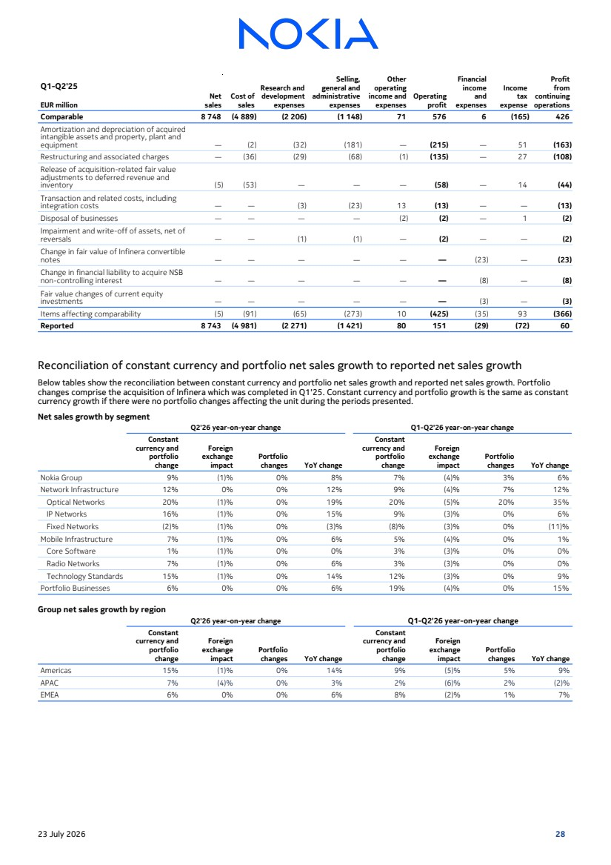 | Q1-Q2'25 Net sales Cost of sales Research and development expenses Selling, general and administrative expenses Other operating income and expenses Operating profit Financial income and expenses Income tax expense Profit from continuing EUR million operations Comparable 8 748 (4 889) (2 206) (1 148) 71 576 6 (165) 426 Amortization and depreciation of acquired intangible assets and property, plant and equipment — (2) (32) (181) — (215) — 51 (163) Restructuring and associated charges — (36) (29) (68) (1) (135) — 27 (108) Release of acquisition-related fair value adjustments to deferred revenue and inventory (5) (53) — — — (58) — 14 (44) Transaction and related costs, including integration costs — — (3) (23) 13 (13) — — (13) Disposal of businesses — — — — (2) (2) — 1 (2) Impairment and write-off of assets, net of reversals — — (1) (1) — (2) — — (2) Change in fair value of Infinera convertible notes — — — — — — (23) — (23) Change in financial liability to acquire NSB non-controlling interest — — — — — — (8) — (8) Fair value changes of current equity investments — — — — — — (3) — (3) Items affecting comparability (5) (91) (65) (273) 10 (425) (35) 93 (366) Reported 8 743 (4 981) (2 271) (1 421) 80 151 (29) (72) 60 Reconciliation of constant currency and portfolio net sales growth to reported net sales growth Below tables show the reconciliation between constant currency and portfolio net sales growth and reported net sales growth. Portfolio changes comprise the acquisition of Infinera which was completed in Q1'25. Constant currency and portfolio growth is the same as constant currency growth if there were no portfolio changes affecting the unit during the periods presented. Net sales growth by segment Q2'26 year-on-year change Q1-Q2'26 year-on-year change Constant currency and portfolio change Foreign exchange impact Portfolio changes YoY change Constant currency and portfolio change Foreign exchange impact Portfolio changes YoY change Nokia Group 9% (1)% 0% 8% 7% (4)% 3% 6% Network Infrastructure 12% 0% 0% 12% 9% (4)% 7% 12% Optical Networks 20% (1)% 0% 19% 20% (5)% 20% 35% IP Networks 16% (1)% 0% 15% 9% (3)% 0% 6% Fixed Networks (2)% (1)% 0% (3)% (8)% (3)% 0% (11)% Mobile Infrastructure 7% (1)% 0% 6% 5% (4)% 0% 1% Core Software 1% (1)% 0% 0% 3% (3)% 0% 0% Radio Networks 7% (1)% 0% 6% 3% (3)% 0% 0% Technology Standards 15% (1)% 0% 14% 12% (3)% 0% 9% Portfolio Businesses 6% 0% 0% 6% 19% (4)% 0% 15% Group net sales growth by region Q2'26 year-on-year change Q1-Q2'26 year-on-year change Constant currency and portfolio change Foreign exchange impact Portfolio changes YoY change Constant currency and portfolio change Foreign exchange impact Portfolio changes YoY change Americas 15% (1)% 0% 14% 9% (5)% 5% 9% APAC 7% (4)% 0% 3% 2% (6)% 2% (2)% EMEA 6% 0% 0% 6% 8% (2)% 1% 7% 23 July 2026 28
 | 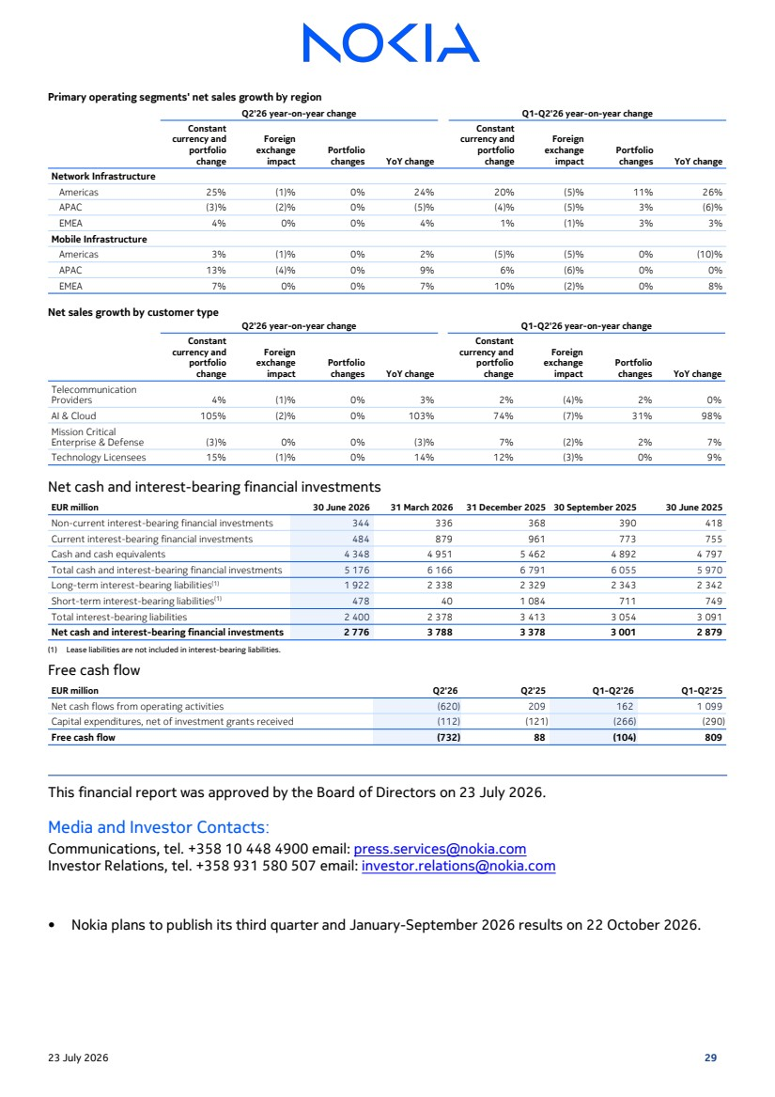 | Primary operating segments' net sales growth by region Q2'26 year-on-year change Q1-Q2'26 year-on-year change Constant currency and portfolio change Foreign exchange impact Portfolio changes YoY change Constant currency and portfolio change Foreign exchange impact Portfolio changes YoY change Network Infrastructure Americas 25% (1)% 0% 24% 20% (5)% 11% 26% APAC (3)% (2)% 0% (5)% (4)% (5)% 3% (6)% EMEA 4% 0% 0% 4% 1% (1)% 3% 3% Mobile Infrastructure Americas 3% (1)% 0% 2% (5)% (5)% 0% (10)% APAC 13% (4)% 0% 9% 6% (6)% 0% 0% EMEA 7% 0% 0% 7% 10% (2)% 0% 8% Net sales growth by customer type Q2'26 year-on-year change Q1-Q2'26 year-on-year change Constant currency and portfolio change Foreign exchange impact Portfolio changes YoY change Constant currency and portfolio change Foreign exchange impact Portfolio changes YoY change Telecommunication Providers 4% (1)% 0% 3% 2% (4)% 2% 0% AI & Cloud 105% (2)% 0% 103% 74% (7)% 31% 98% Mission Critical Enterprise & Defense (3)% 0% 0% (3)% 7% (2)% 2% 7% Technology Licensees 15% (1)% 0% 14% 12% (3)% 0% 9% Net cash and interest-bearing financial investments EUR million 30 June 2026 31 March 2026 31 December 2025 30 September 2025 30 June 2025 Non-current interest-bearing financial investments 344 336 368 390 418 Current interest-bearing financial investments 484 879 961 773 755 Cash and cash equivalents 4 348 4 951 5 462 4 892 4 797 Total cash and interest-bearing financial investments 5 176 6 166 6 791 6 055 5 970 Long-term interest-bearing liabilities(1) 1 922 2 338 2 329 2 343 2 342 Short-term interest-bearing liabilities(1) 478 40 1 084 711 749 Total interest-bearing liabilities 2 400 2 378 3 413 3 054 3 091 Net cash and interest-bearing financial investments 2 776 3 788 3 378 3 001 2 879 (1) Lease liabilities are not included in interest-bearing liabilities. Free cash flow EUR million Q2'26 Q2'25 Q1-Q2'26 Q1-Q2'25 Net cash flows from operating activities (620) 209 162 1 099 Capital expenditures, net of investment grants received (112) (121) (266) (290) Free cash flow (732) 88 (104) 809 This financial report was approved by the Board of Directors on 23 July 2026. Media and Investor Contacts: Communications, tel. +358 10 448 4900 email: press.services@nokia.com Investor Relations, tel. +358 931 580 507 email: investor.relations@nokia.com • Nokia plans to publish its third quarter and January-September 2026 results on 22 October 2026. 23 July 2026 29

1

STOCK EXCHANGE RELEASE 23 July 2026

Nokia Corporation
Stock Exchange Release
23 July 2026 at 8:15 EEST

Nokia provides recast comparative financial information reflecting the presentation of Fixed Wireless Access CPE and Enterprise Campus Edge businesses as discontinued operations

Nokia today provides recast comparative financial information for Nokia Group and its reportable segments for Q1 2026 and Q1-Q4 2025 reflecting the presentation of Fixed Wireless Access CPE and Enterprise Campus Edge businesses as discontinued operations.

Presentation of Fixed Wireless Access CPE and Enterprise Campus Edge businesses as discontinued operations

As part of the strategy work that led to Nokia's new strategy and reorganization of its business into two primary operating segments, Nokia identified several units which were not seen as core to the future of the company's strategy. These units were moved into a dedicated operating segment called Portfolio Businesses beginning from 1 January 2026 while the company continued to assess the best value creating opportunity for them. During Q2 2026, Nokia classified the Fixed Wireless Access CPE and Enterprise Campus Edge businesses included in the Portfolio Businesses segment as discontinued operations. This followed the agreement Nokia reached to sell its Fixed Wireless Access CPE business and its assessment that it is highly probable it will reach an agreement to sell Enterprise Campus Edge. Classification of these businesses as discontinued operations had also a minor impact on the financial information for Network Infrastructure and Mobile Infrastructure segments due to the scope of expected transactions and centrally allocated costs. For more information on Nokia’s current operational and reporting structure and discontinued operations, refer to Note 2. Segment information and Note 3. Discontinued operations and disposal groups held for sale in Nokia’s Report for Q2 and Half Year 2026.

To provide a basis for comparison, the following tables present summarized income statement information for Nokia Group and its reportable segments on an unaudited basis for all quarters and the full year of 2025, as well as for the first two quarters and first half of 2026, reflecting the presentation of Fixed Wireless Access CPE and Enterprise Campus Edge businesses as discontinued operations.

Tables in Excel are attached to this stock exchange release.

2
STOCK EXCHANGE RELEASE 23 July 2026

Nokia Group

Reported
 |  | Recast
EUR million |  | Q1'25 |  |  |  | Q2'25 |  |  |  | Q3'25 |  |  |  | Q4'25 |  |  |  | Q1-Q4'25 |  |  |  | Q1'26 |  |  |  | Q2’26 |  |  |  | Q1-Q2’26
Net sales |  |  | 4 300 |  |  |  | 4 443 |  |  |  | 4 700 |  |  |  | 6 021 |  |  |  | 19 464 |  |  |  | 4 433 |  |  |  | 4 815 |  |  |  | 9 248
Gross profit |  |  | 1 809 |  |  |  | 1 953 |  |  |  | 2 085 |  |  |  | 2 739 |  |  |  | 8 587 |  |  |  | 1 977 |  |  |  | 2 146 |  |  |  | 4 123
Gross margin % |  |  | 42.1 | % |  |  | 44.0 | % |  |  | 44.4 | % |  |  | 45.5 | % |  |  | 44.1 | % |  |  | 44.6 | % |  |  | 44.6 | % |  |  | 44.6 | %
Research and development expenses |  |  | (1 127) |  |  |  | (1 143) |  |  |  | (1 155) |  |  |  | (1 350) |  |  |  | (4 776) |  |  |  | (1 223) |  |  |  | (1 383) |  |  |  | (2 606)
Selling, general and administrative expenses |  |  | (701 | ) |  |  | (721 | ) |  |  | (710 | ) |  |  | (854 | ) |  |  | (2 985) |  |  |  | (647 | ) |  |  | (817 | ) |  |  | (1 464)
Other operating income and expenses |  |  | 23 |  |  |  | 58 |  |  |  | 31 |  |  |  | 39 |  |  |  | 151 |  |  |  | (24 | ) |  |  | 4 |  |  |  | (19 | )
Operating profit/(loss) |  |  | 4 |  |  |  | 147 |  |  |  | 252 |  |  |  | 575 |  |  |  | 977 |  |  |  | 83 |  |  |  | (50 | ) |  |  | 33
Operating margin % |  |  | 0.1 | % |  |  | 3.3 | % |  |  | 5.4 | % |  |  | 9.5 | % |  |  | 5.0 | % |  |  | 1.9 | % |  |  | (1.0 | %) |  |  | 0.4 | %
Profit/(loss) from continuing operations |  |  | (39 | ) |  |  | 99 |  |  |  | 90 |  |  |  | 562 |  |  |  | 712 |  |  |  | 104 |  |  |  | 27 |  |  |  | 131
Profit/(loss) for the period |  |  | (60 | ) |  |  | 96 |  |  |  | 80 |  |  |  | 544 |  |  |  | 660 |  |  |  | 87 |  |  |  | 5 |  |  |  | 92

Comparable
 |  | Recast
EUR million |  | Q1'25 |  |  |  | Q2'25 |  |  |  | Q3'25 |  |  |  | Q4'25 |  |  |  | Q1-Q4'25 |  |  |  | Q1'26 |  |  |  | Q2’26 |  |  |  | Q1-Q2’26
Net sales |  |  | 4 300 |  |  |  | 4 448 |  |  |  | 4 705 |  |  |  | 6 026 |  |  |  | 19 480 |  |  |  | 4 436 |  |  |  | 4 815 |  |  |  | 9 251
Gross profit |  |  | 1 842 |  |  |  | 2 017 |  |  |  | 2 109 |  |  |  | 2 920 |  |  |  | 8 889 |  |  |  | 2 038 |  |  |  | 2 216 |  |  |  | 4 253
Gross margin % |  |  | 42.8 | % |  |  | 45.3 | % |  |  | 44.8 | % |  |  | 48.5 | % |  |  | 45.6 | % |  |  | 45.9 | % |  |  | 46.0 | % |  |  | 46.0 | %
Research and development expenses |  |  | (1 097) |  |  |  | (1 109) |  |  |  | (1 104) |  |  |  | (1 231) |  |  |  | (4 541) |  |  |  | (1 137) |  |  |  | (1 197) |  |  |  | (2 334)
Selling, general and administrative expenses |  |  | (559 | ) |  |  | (589 | ) |  |  | (590 | ) |  |  | (664 | ) |  |  | (2 402) |  |  |  | (588 | ) |  |  | (589 | ) |  |  | (1 177)
Other operating income and expenses |  |  | 23 |  |  |  | 48 |  |  |  | 33 |  |  |  | 42 |  |  |  | 145 |  |  |  | (11 | ) |  |  | 5 |  |  |  | (7 | )
Operating profit |  |  | 209 |  |  |  | 367 |  |  |  | 448 |  |  |  | 1 067 |  |  |  | 2 092 |  |  |  | 301 |  |  |  | 434 |  |  |  | 735
Operating margin % |  |  | 4.9 | % |  |  | 8.3 | % |  |  | 9.5 | % |  |  | 17.7 | % |  |  | 10.7 | % |  |  | 6.8 | % |  |  | 9.0 | % |  |  | 7.9 | %
Profit/(loss) from continuing operations |  |  | 174 |  |  |  | 252 |  |  |  | 334 |  |  |  | 884 |  |  |  | 1 644 |  |  |  | 311 |  |  |  | 414 |  |  |  | 726
Profit/(loss) for the period |  |  | 174 |  |  |  | 252 |  |  |  | 334 |  |  |  | 884 |  |  |  | 1 644 |  |  |  | 311 |  |  |  | 414 |  |  |  | 726

Network Infrastructure

 |  | Recast
EUR million |  | Q1'25 |  |  |  | Q2'25 |  |  |  | Q3'25 |  |  |  | Q4'25 |  |  |  | Q1-Q4'25 |  |  |  | Q1'26 |  |  |  | Q2’26 |  |  |  | Q1-Q2’26
Net sales |  |  | 1 639 |  |  |  | 1 825 |  |  |  | 1 850 |  |  |  | 2 332 |  |  |  | 7 646 |  |  |  | 1 829 |  |  |  | 2 037 |  |  |  | 3 866
Gross profit |  |  | 686 |  |  |  | 736 |  |  |  | 790 |  |  |  | 1 067 |  |  |  | 3 278 |  |  |  | 792 |  |  |  | 870 |  |  |  | 1 662
Gross margin % |  |  | 41.9 | % |  |  | 40.3 | % |  |  | 42.7 | % |  |  | 45.8 | % |  |  | 42.9 | % |  |  | 43.3 | % |  |  | 42.7 | % |  |  | 43.0 | %
Research and development expenses |  |  | (344 | ) |  |  | (374 | ) |  |  | (392 | ) |  |  | (410 | ) |  |  | (1 520) |  |  |  | (398 | ) |  |  | (428 | ) |  |  | (825 | )
Selling, general and administrative expenses |  |  | (229 | ) |  |  | (253 | ) |  |  | (256 | ) |  |  | (275 | ) |  |  | (1 013) |  |  |  | (268 | ) |  |  | (272 | ) |  |  | (540 | )
Other operating income and expenses |  |  | (1 | ) |  |  | 8 |  |  |  | 1 |  |  |  | 6 |  |  |  | 14 |  |  |  | (6 | ) |  |  | (4 | ) |  |  | (10 | )
Operating profit |  |  | 113 |  |  |  | 117 |  |  |  | 143 |  |  |  | 387 |  |  |  | 760 |  |  |  | 121 |  |  |  | 166 |  |  |  | 287
Operating margin % |  |  | 6.9 | % |  |  | 6.4 | % |  |  | 7.7 | % |  |  | 16.6 | % |  |  | 9.9 | % |  |  | 6.6 | % |  |  | 8.2 | % |  |  | 7.4 | %

3
STOCK EXCHANGE RELEASE 23 July 2026

Mobile Infrastructure

 |  | Recast
EUR million |  | Q1'25 |  |  |  | Q2'25 |  |  |  | Q3'25 |  |  |  | Q4'25 |  |  |  | Q1-Q4'25 |  |  |  | Q1'26 |  |  |  | Q2’26 |  |  |  | Q1-Q2’26
Net sales |  |  | 2 579 |  |  |  | 2 531 |  |  |  | 2 755 |  |  |  | 3 579 |  |  |  | 11 445 |  |  |  | 2 503 |  |  |  | 2 680 |  |  |  | 5 183
Gross profit |  |  | 1 140 |  |  |  | 1 266 |  |  |  | 1 302 |  |  |  | 1 817 |  |  |  | 5 525 |  |  |  | 1 213 |  |  |  | 1 320 |  |  |  | 2 533
Gross margin % |  |  | 44.2 | % |  |  | 50.0 | % |  |  | 47.3 | % |  |  | 50.8 | % |  |  | 48.3 | % |  |  | 48.5 | % |  |  | 49.3 | % |  |  | 48.9 | %
Research and development expenses |  |  | (720 | ) |  |  | (701 | ) |  |  | (683 | ) |  |  | (785 | ) |  |  | (2 890) |  |  |  | (708 | ) |  |  | (735 | ) |  |  | (1 443)
Selling, general and administrative expenses |  |  | (310 | ) |  |  | (293 | ) |  |  | (295 | ) |  |  | (338 | ) |  |  | (1 235) |  |  |  | (283 | ) |  |  | (283 | ) |  |  | (566 | )
Other operating income and expenses |  |  | 24 |  |  |  | 39 |  |  |  | 31 |  |  |  | 38 |  |  |  | 131 |  |  |  | 0 |  |  |  | 8 |  |  |  | 8
Operating profit |  |  | 134 |  |  |  | 310 |  |  |  | 355 |  |  |  | 732 |  |  |  | 1 531 |  |  |  | 222 |  |  |  | 310 |  |  |  | 532
Operating margin % |  |  | 5.2 | % |  |  | 12.3 | % |  |  | 12.9 | % |  |  | 20.4 | % |  |  | 13.4 | % |  |  | 8.9 | % |  |  | 11.6 | % |  |  | 10.3 | %

Portfolio Businesses

 |  | Recast
EUR million |  | Q1'25 |  |  |  | Q2'25 |  |  |  | Q3'25 |  |  |  | Q4'25 |  |  |  | Q1-Q4'25 |  |  |  | Q1'26 |  |  |  | Q2’26 |  |  |  | Q1-Q2’26
Net sales |  |  | 80 |  |  |  | 89 |  |  |  | 97 |  |  |  | 113 |  |  |  | 379 |  |  |  | 100 |  |  |  | 94 |  |  |  | 194
Gross profit |  |  | 21 |  |  |  | 15 |  |  |  | 18 |  |  |  | 35 |  |  |  | 90 |  |  |  | 33 |  |  |  | 27 |  |  |  | 60
Gross margin % |  |  | 27.0 | % |  |  | 17.4 | % |  |  | 18.6 | % |  |  | 30.8 | % |  |  | 23.7 | % |  |  | 32.7 | % |  |  | 29.3 | % |  |  | 31.0 | %
Research and development expenses |  |  | (17 | ) |  |  | (18 | ) |  |  | (13 | ) |  |  | (18 | ) |  |  | (65 | ) |  |  | (18 | ) |  |  | (19 | ) |  |  | (37 | )
Selling, general and administrative expenses |  |  | (10 | ) |  |  | (10 | ) |  |  | (10 | ) |  |  | (12 | ) |  |  | (42 | ) |  |  | (7 | ) |  |  | (8 | ) |  |  | (16 | )
Other operating income and expenses |  |  | 0 |  |  |  | 1 |  |  |  | 1 |  |  |  | (2 | ) |  |  | 1 |  |  |  | (5 | ) |  |  | (1 | ) |  |  | (5 | )
Operating profit/(loss) |  |  | (6 | ) |  |  | (11 | ) |  |  | (4 | ) |  |  | 4 |  |  |  | (17 | ) |  |  | 3 |  |  |  | 0 |  |  |  | 2
Operating margin % |  |  | (7.3 | %) |  |  | (12.5 | %) |  |  | (4.3 | %) |  |  | 3.5 | % |  |  | (4.5 | %) |  |  | 2.9 | % |  |  | (0.5 | %) |  |  | 1.3 | %

About Nokia

Nokia is a global leader in connectivity for the AI era. With expertise across fixed, mobile, and transport networks, we’re advancing connectivity to secure a brighter world.

Inquiries:

Nokia
Communications
Phone: +358 10 448 4900
Email: press.services@nokia.com
Maria Vaismaa, Vice President, Corporate Communications

Nokia
Investor Relations
Phone: +358 931 580 507
Email: investor.relations@nokia.com

SIGNATURE

Pursuant to the requirements of the Securities Exchange Act of 1934, the registrant, Nokia Corporation, has duly caused this report to be signed on its behalf by the undersigned, thereunto duly authorized.

Date: July 23, 2026 | Nokia Corporation
 | By: | /s/ Johanna Mandelin
 | Name: | Johanna Mandelin
 | Title: | Global Head of Corporate Legal

